PROJECT REPORT

ON

CABLE SERVICE SUBSCRIPTION WEBSITE

(FOR THE COURSE OF T. Y. B.SC.

COMPUTER SCIENCE)

DESIGNED AND DEVELOPED

BY

Mr. VIHANG RAJENDRA PIMPALE

GUIDED BY

Ms. PRATIKSHA HARWARKAR

DEPARTMENT OF COMPUTER SCIENCE

PARLE TILAK VIDYALAYA ASSOCIATION’S

MULUND COLLEGE OF COMMERCE (AUTONOMOUS)

*(AFFILIATED TO UNIVERSITY OF MUMBAI)*

2024-2025

MULUND (WEST), MUMBAI-400080

MAHARASHTRA, INDIA

**ACKNOWLEDGEMENT**

I have a great pleasure in representing this project report entitled “Cable Service Website” and I grab this opportunity to convey my immense regards towards all the distinguished people who have their valuable contribution in the hour of need.

I like to extend my gratitude to our beloved Principal Dr. Sonali Pednekar for her timely and prestigious guidance.

I take this opportunity to thank Dr. Reena Nagda, Coordinator of the Department and all the faculty members of the Department of Computer Science of Mulund College of Commerce, for giving me an opportunity to complete this project and the most needed guidance throughout the duration of the programme.

I am extremely grateful to my project guide Ms. Pratiksha Harwalkarfor her valuable guidance and necessary support during each phase of the project. She was the source of continuous encouragement as each milestone was crossed.

Finally, I also owe to my fellow friends who have been a constant source of help to solve the problems that cropped up during the project development process.

VIHANG RAJENDRA PIMPALE

**PLAGARISM CHECKER:**

Plagiarism Checker X Originality Report

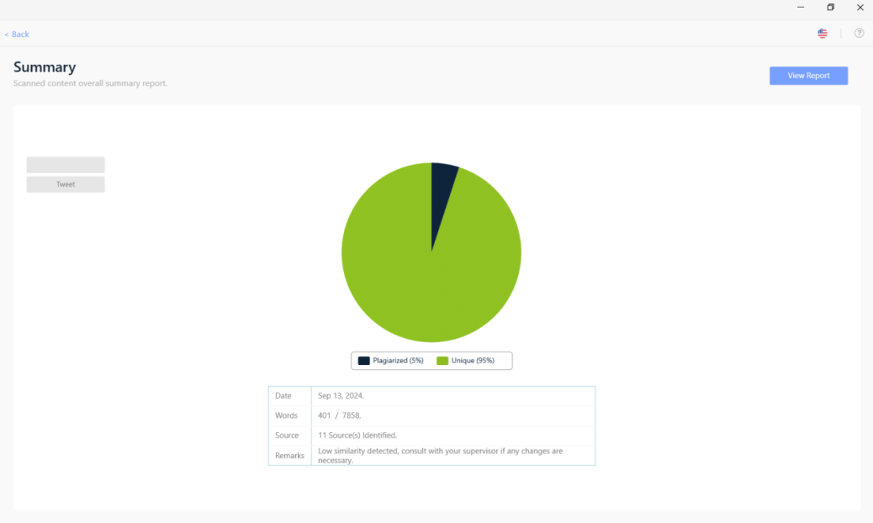

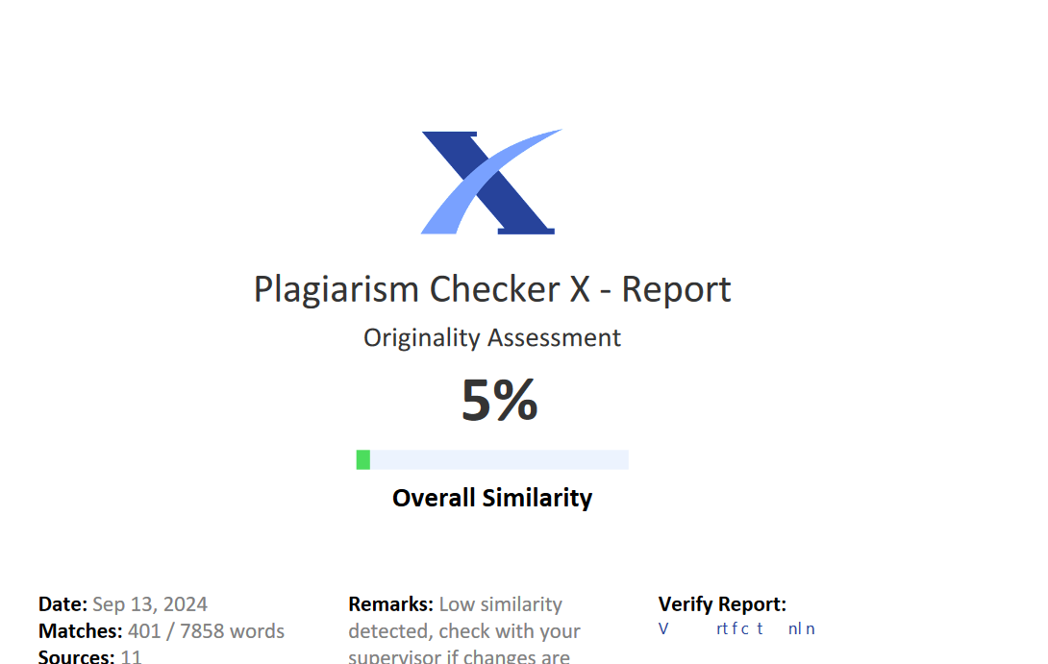



**INDEX**

1.Title 1

1.1 Title Of Project 1

1.2 Type Of Project 1

1.3 Developed By 1

2. Introduction 2

2.1 Objective Of Project 2

2.2 Description Of The Current System 2

2.3 Limitations Of The Current System 3

2.4 Description Of The Proposed System 3

2.5 Advantages Of The Proposed System 4

3. Requirement Specification 5

3.1 Software Requirements 5

3.2 Hardware Requirements 5

3.3 Data Requirements 5

3.4 Fact Finding Questions 5

4.System Design: 6

4.1 Event Table : 6

4.2 Class Diagram: 8

4.3 Usecase Diagram: 9

4.3.1 Customer Use Case Diagram: 9

4.3.2 Admin Use Case Diagram: 9

4.4 Sequence Diagram: 10

4.5 Activity Diagram: 11

4.5.1 Activity Diagram (User Side) 11

4.5.2 Activity Diagram (Admin Side): 12

4.6. State Diagram 13

4.6.1 State Diagram (User Side): 13

4.6.2 State Diagram (Admin Side): 14

4.7 Package Diagram: 15

4.8 Component Diagram: 15

4.9 Deployment Diagram: 16

4.10 Database Design: 17

4.10.1 User: 17

4.10.2 Channels: 18

4.10.3 Packages: 19

4.10.4 User_Channels: 20

4.10.5 User_Subscriptions: 21

4.10.6 New_Channels: 21

4.10.7 New_Packages: 22

4.10.8 New_Userchannels: 24

4.10.9 New_Usersubscriptions: 25

5.System Implementation: 28

PHP Files: 28

5.1.Home.Php: 28

5.2.Channels.Php: 31

5.3.Packages.Php: 39

5.4.Login.Php: 45

5.5.Payment_Channel.Php: 46

5.6.Payment_Packages.Php: 49

5.7.Add_Channel.Php : 52

5.8.Add_Package.Php: 53

5.9.User_Account.Php: 55

5.10.Admin_Dashboard.Php: 62

5.11.Edit_Users.Php: 64

5.12. Delete_User.Php: 67

5.13.Edit_Channel.Php: 67

5.14. Delete_Channel.Php: 70

5.15.Edit_Package.Php: 70

5.16. Delete_Package.Php: 73

5.17.Tour.Php: 74

5.18.About.Php: 76

6.Results 80

6.1 Validation And Naming Conventions: 80

6.2 Screenshots: 81

6.2.1 Package Details Page: 81

6.2.2 Register Page: 82

6.2.3 Payment Page: 83

6.2.4 Channels Page: 84

6.2.5 User Account Page: 85

6.2.6 Packages Page: 86

6.2.7 About Us Page: 87

6.2.8 Home Page: 88

6.2.9 Login Page: 89

6.2.10 Admin Dashboard Page: 90

6.2.11 Admin Users Page: 91

6.2.12 Admin Channel Page: 92

6.2.13 Admin Package Page: 93

7. Future Enhancement & Conclusion: 94

7.1 Future Enhancement: 94

7.2 Conclusions: 94

8.References: 95

9 Annexures 96

9.1 Figure List 96

9.2 Table List 96

# 

# 1.Title

## 1.1 Title of Project

SOLAIRE

## 1.2 Type of Project

SUBSCRIPTION-BASED WEBSITE

## 1.3 Developed by

VIHANG PIMPALE

# 2. Introduction

## 2.1 Objective of Project

1. **Subscription Management**: Develop a user-friendly platform that allows users to easily subscribe to cable TV packages and individual channels, with secure payment integration for seamless transactions.
2. **Customizable Viewing Options**: Enable users to browse a wide range of cable TV packages and channels, offering personalized recommendations based on user preferences and viewing history.
3. **Account and Subscription Management**: Provide a user dashboard where subscribers can manage their account details, view current subscriptions, and upgrade or modify their cable services as needed.
4. **Admin Functionality**: Create an admin panel that allows administrators to add, edit, and delete channels and packages, as well as manage user subscriptions and generate reports for business insights.
5. **Scalable and Secure System**: Implement a scalable and secure website architecture, ensuring data protection, user privacy, and the ability to handle a growing number of subscribers and package offerings efficiently.

## 2.2 Description of the Current System

• **Overview of Features and Services with Visuals**:

* Comprehensive descriptions and high-quality images of available channels and packages.

• **Subscription Plans, Pricing, and Online Sign-Up**:

* Clear pricing details for individual channels and bundles, with an easy online sign-up process.

• **Real-Time Program Guide**:

* Up-to-date listings of current and upcoming shows across all subscribed channels.

• **User Account Management Tools**:

* Manage subscriptions, view payment history, and track service renewals.

• **Customization and Add-Ons**:

* Options to customize subscriptions by adding or removing channels and upgrading packages.

## 2.3 Limitations of the Current System

• Limited Coverage Area:

* The service may only be available in specific geographic regions, restricting access for users outside these areas.

• Channel Availability Variations:

* Some channels or packages might not be available in all regions, leading to inconsistent service offerings.

• Technical Issues and Downtime:

* Users might experience technical problems or downtime affecting the availability of the service or its features.

• Complex Subscription Management:

* Users could face difficulties in managing their subscriptions or understanding the pricing structure, especially if it involves multiple add-ons and packages.

• Data Privacy Concerns:

* Handling sensitive user information, including payment details, could pose privacy risks if not managed with stringent security measures.

## 2.4 Description of the Proposed System

1. **Comprehensive Cable Packages**:
   * Offers a variety of cable TV packages and channels, catering to different preferences and budgets.
2. **User-Friendly Subscription Management**:
   * Allows users to easily subscribe to, view, and manage their cable TV packages and individual channels through an intuitive interface.
3. **Admin Dashboard for Package and Channel Management**:
   * Provides administrators with tools to add, edit, and delete cable packages and channels, ensuring up-to-date offerings.
4. **Secure Payment System**:
   * Features a secure payment gateway for processing transactions related to new subscriptions and package upgrades.
5. **Enhanced User Experience**:
   * Includes functionalities like account management, subscription history, and support for newly added channels and packages to enhance overall user satisfaction.

## 2.5 Advantages of the Proposed System

• Streamlined **Subscription Management**:

* Users can easily browse, subscribe to, and manage cable packages and channels, providing a seamless and user-friendly experience.

• Flexible **and Up-to-Date Offerings**:

* The system allows for real-time updates and additions of new channels and packages, ensuring users always have access to the latest content.

• Efficient **Admin Controls**:

* Admins have robust tools for managing packages and channels, including the ability to add, edit, and delete offerings, which simplifies content management.

# 3. Requirement Specification

## 3.1 Software Requirements

* Operating System: Microsoft Windows 10.
* Application Software:
  + Front End: HTML, CSS.
  + Back End: PHP, MySQL, JavaScript.
* Platform: VS Code.

## 3.2 Hardware Requirements

* Processor: 1.6 Ghz.
* Ram: Minimum 4GB.
* Disk Space: 1GB or less

## 3.3 Data Requirements

* Username
* age
* Email
* Password

## 3.4 Fact Finding Questions

• What channels or packages are most frequently subscribed to by users?

• What additional features or channels do users wish were available?

• What are the most common issues users face with the subscription or payment process?

• How do users prefer to manage their subscriptions (e.g., via website, mobile app)?

• What payment methods do users prefer for their subscriptions?

• What are the common reasons users cancel or modify their subscriptions?

# 4.System Design:

## 4.1 Event Table:

|  |  |  |  |  |  |  |
| --- | --- | --- | --- | --- | --- | --- |
| **Sr.No** | **Events** | **Trigger** | **Source** | **Activity** | **Response** | **Destination** |
| 1 | User  Registration | register-btn | User | Filling Form Details | If successfull redirect to login interface or else error | logreg.php |
| 2 | User Login | login-btn | User | Entering registered username/email And password | If username/Email and Password are correct then logged in or else error | Login.php |
| 3 | User Panel | dashboard-btn | User | To manage the user data | Displays the data by user and able to manage it | homes.php |
| 4 | home | home-btn | User | To view the tours of different categories | Displaying the offerings of our cable site | homes.php |
| 5 | About | about-btn | User | To view  about the page | Displays the about page | about.page |
| 6 | channel | channel-btn | User | To view the channels | Displays the channels | channels.php |
| 7 | package | package-btn | User | To view the packages | Displays the packages | packages.php |
| 8 | Admin  Login | signin-btn | Admin | Entering the admin username/email and  password | If username/  Email and  Password are correct then logged in or else error | logreg.php |
| 9 | Admin  Panel | dashboard-btn | Admin | To edit delete and update the user | Displays all the user and categories and manage them all | Home.php |
| 10 | Payment_channel | payment-btn | User | To input card details from the user | Redirects to page |  |

## 4.2 Class Diagram:

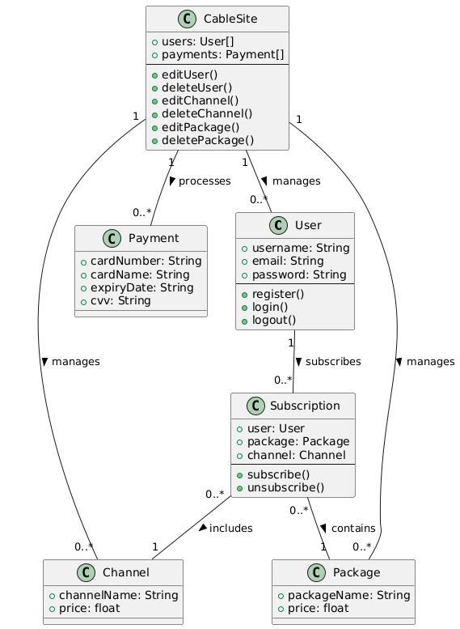

## 4.3 Usecase Diagram:

### 4.3.1 Customer Use case Diagram:

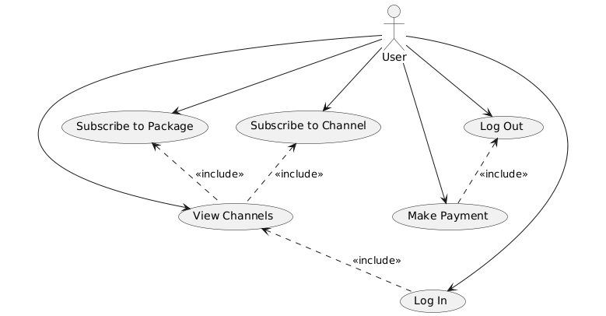

### 4.3.2 Admin Use case Diagram:

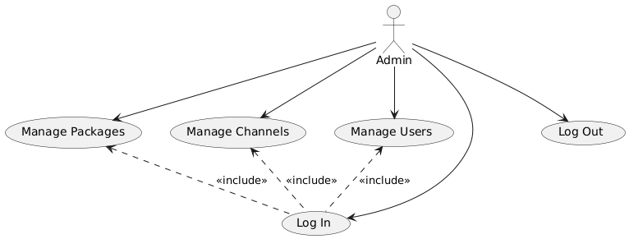

## 4.4 Sequence Diagram:

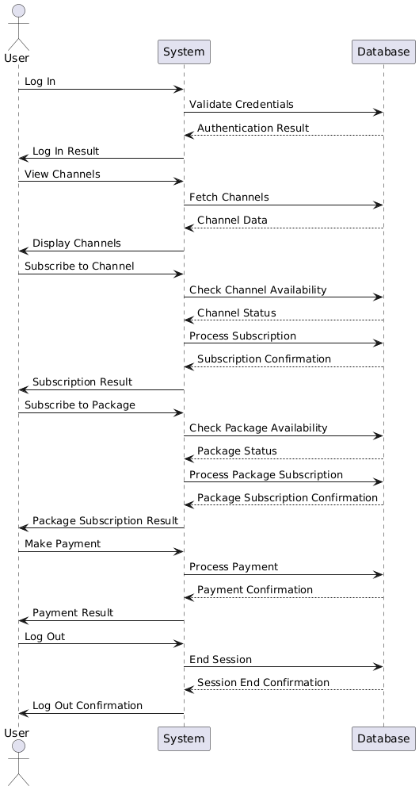

## 4.5 Activity Diagram:

4.5.1 Activity Diagram (User side)

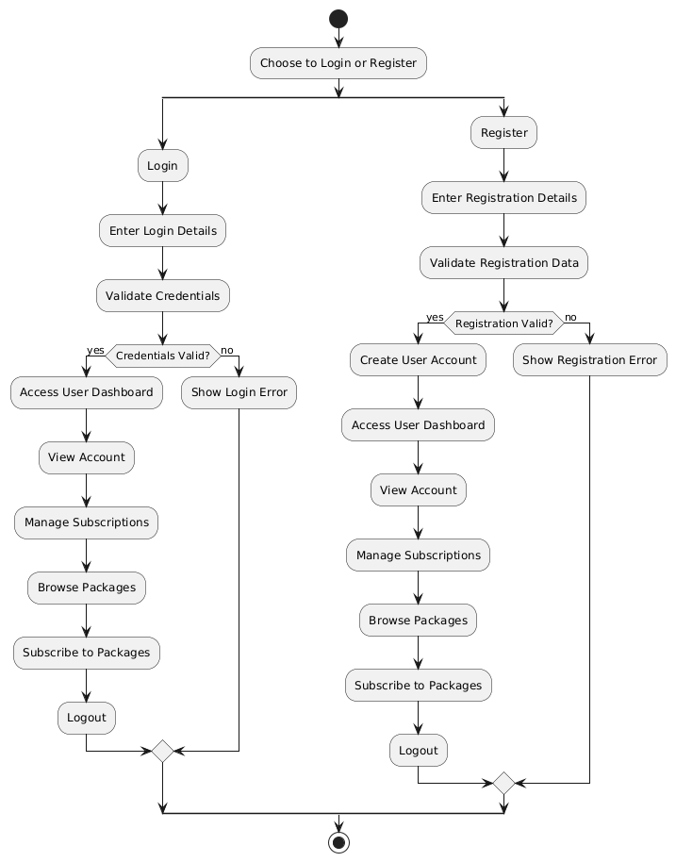

### 4.5.2 Activity Diagram (Admin side):

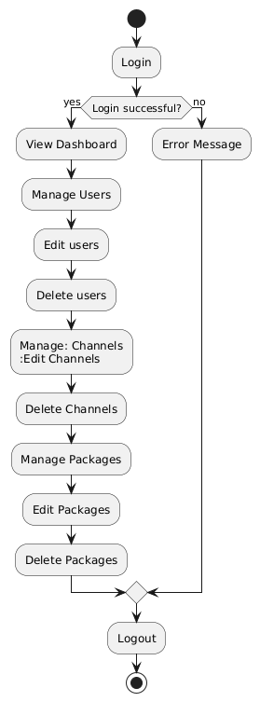

## 4.6. State Diagram

### 4.6.1 State Diagram (User side):

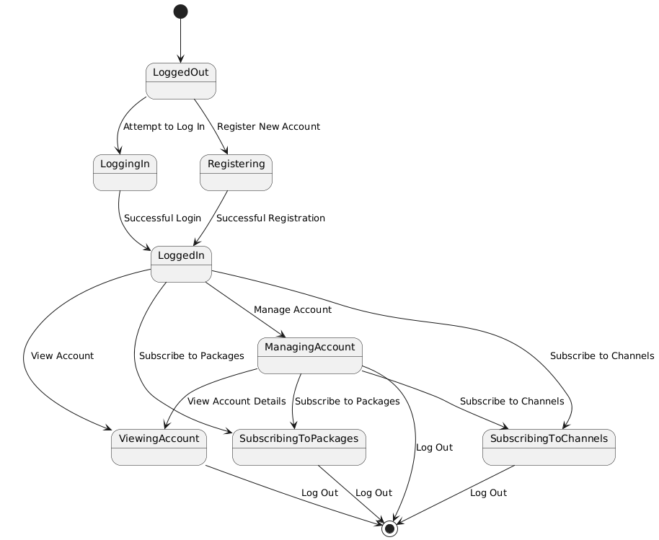

### 4.6.2 State Diagram (Admin side):

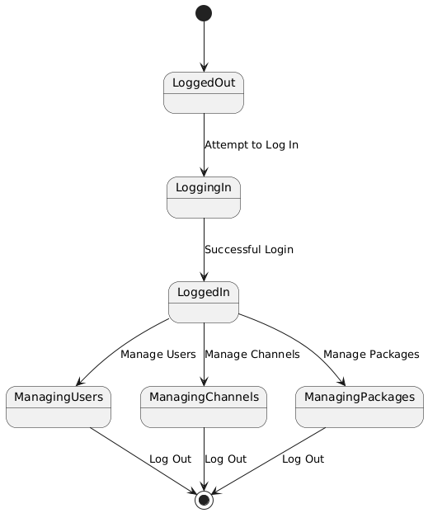

## 4.7 Package diagram:

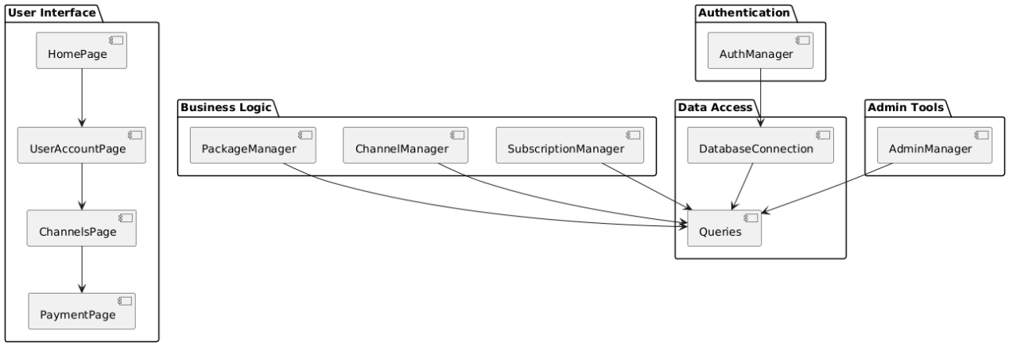

## 4.8 Component diagram:

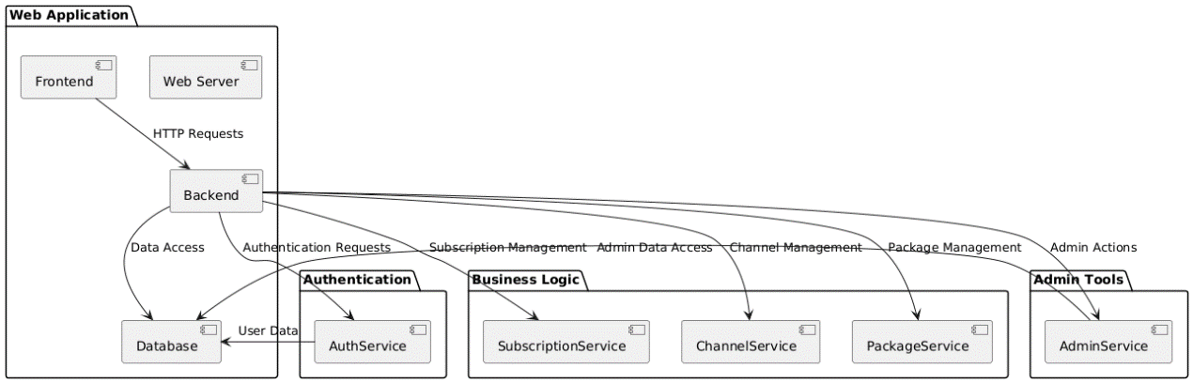

## 4.9 Deployment diagram:

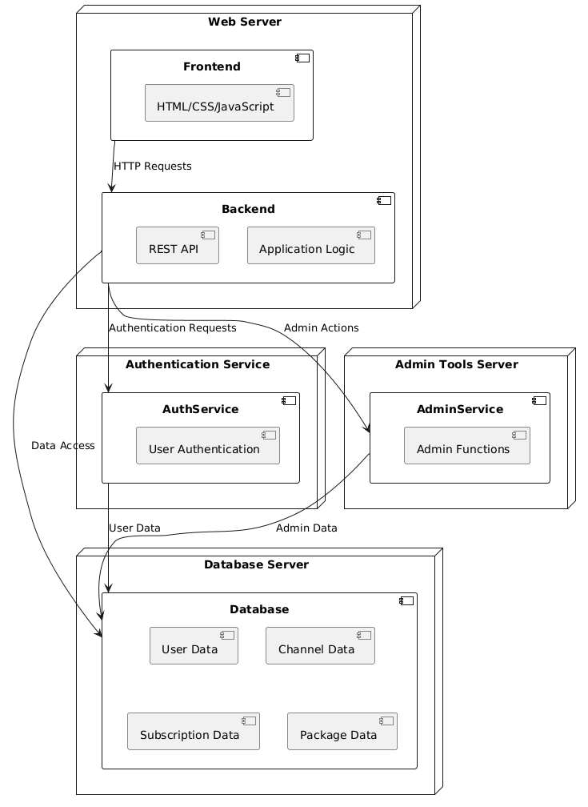

## **4.10 Database Design**:

### 4.10.1 user:

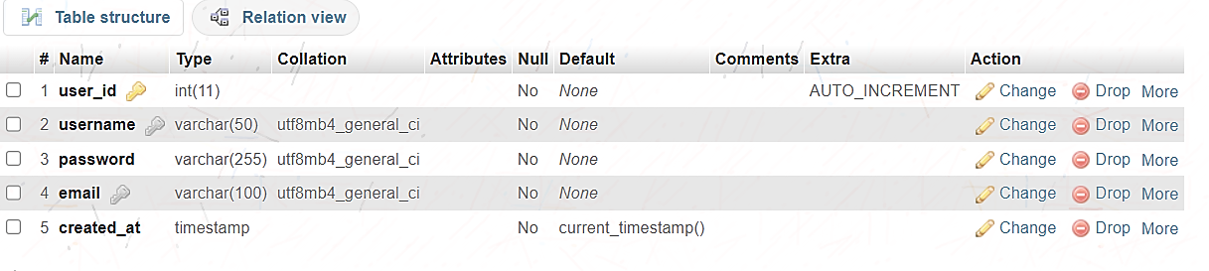 Users Table:

The users table stores user information such as email, username, password, and account creation time. It serves as the main repository for user authentication and identification. Unique constraints ensure that usernames and emails are distinct for each user.

**Purpose:**

* Manages the credentials, registration, and basic details of users.
* Tracks when users signed up, and facilitates user authentication via username or email and password.

### 4.10.2 channels:

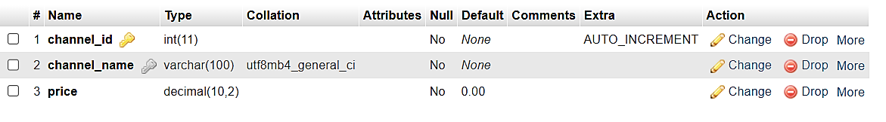 Channels Table:

The channels table stores information about individual channels, including their names and prices. It serves as the catalog of available channels for subscription, with each channel having a unique identifier.

**Purpose:**

Maintains the list of channels that users can browse and subscribe to.

Stores pricing information for each channel, which may be used for billing and subscription purposes.

connected with other tables (like user_channels which track which users are subscribed to specific channel)

### 4.10.3 packages:

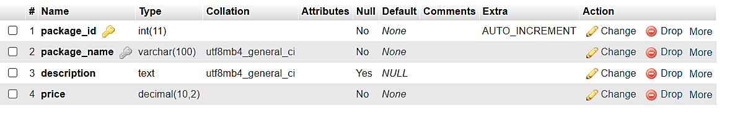

Packages Table:

The packages table stores information about different subscription packages, including package names, descriptions, and prices. It is used to group channels into different bundles that users can subscribe to.

**Purpose:**

Maintains the list of packagess that users can browse and subscribe to.

Stores pricing information for each Package, which may be used for billing and subscription purposes.

connected with other tables (like user_subscriptions which track which users are subscribed to specific channel)

### 

### 4.10.4 user_channels:

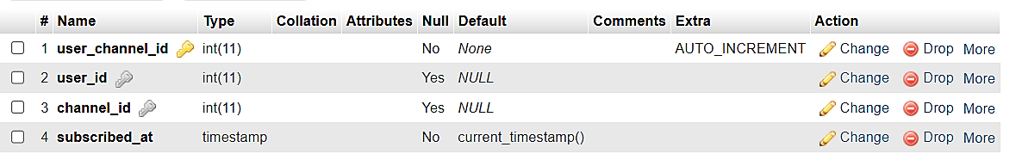

User Channels Table

The user_channels table manages the relationship between users and their subscribed channels. It links users to channels they have subscribed to, recording when the subscription began.

Purpose:

Tracks which channels each user is subscribed to.

Helps in managing subscriptions, allowing the system to associate users with their preferred channels.

used for displaying subscribed channels in the user profile and for billing or usage tracking purposes.

### 4.10.5 user_subscriptions:

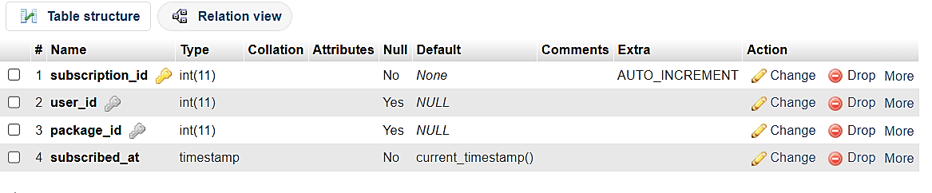 User Subscriptions Table

The user_subscriptions table tracks the relationship between users and the packages they are subscribed to. It records when a user subscribed to a specific package, facilitating subscription management.

Purpose:

Tracks which Packages each user is subscribed to.

Helps in managing subscriptions, allowing the system to associate users with their preferred Packages.

used for displaying subscribed Packages in the user profile and for billing or usage tracking purposes.

### 

### **4.10.6 new_channels:**

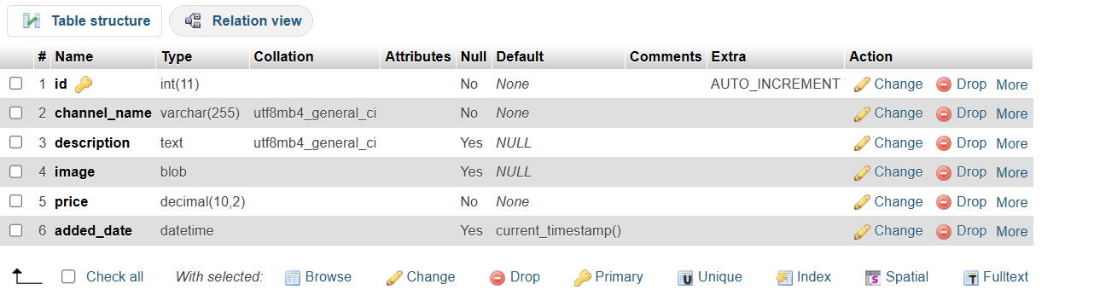

New Channels Table

The new_channels table holds details about newly added channels, including descriptions and images, along with pricing. It’s primarily used to showcase recent additions to the channel lineup.

Purpose:

Used to store detailed information about newly added channels that might be showcased to users.

Works alongside the channels table to highlight new or recently launched channels that users can subscribe to.

### **4.10.7 new_packages:**

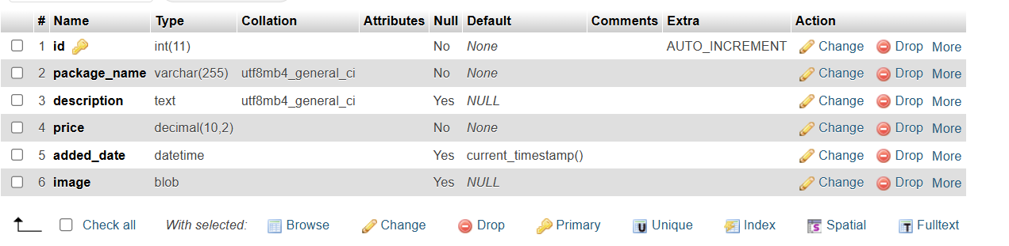

New Packages Table

The new_packages table stores information about newly added subscription packages, including package names, descriptions, images, and prices. It is used to highlight and manage recently introduced package

**Purpose:**

Used to store detailed information about newly added Packages that might be showcased to users.

Works alongside the packages table to highlight new or recently launched channels that users can subscribe to.

### 4.10.8 new_userchannels:

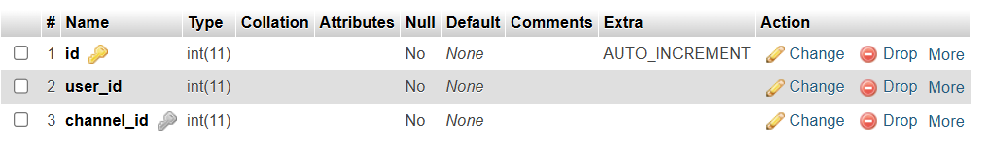

New User Channels Table

The new_userchannels table tracks which users have subscribed to newly added channels. It functions similarly to the user_channels table but focuses on recent or promotional channel offerings.

Purpose:

Tracks the relationship between users and newly added channels.

Similar to the user_channels table, it manages user subscriptions, but likely focuses on newly added or recently promoted channels.

Used for displaying which new channels users are subscribed to

### 4.10.9 new_usersubscriptions:

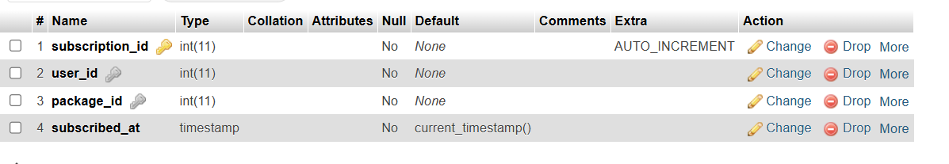 New User Subscriptions Table

The new_usersubscriptions table manages user subscriptions to new packages. It records when users subscribe to new or promotional packages, helping to track the uptake of recent offerings.

Purpose:

Manages user subscriptions to newly introduced packages.

Similar to the user_subscriptions table, but focusing on new or promotional subscription packages.

Helps track user subscriptions to new or updated packages.

**Summary:**

* channels
  + `channel_id`: Primary Key, integer.
  + `channel_name`: Unique, varchar.
  + `price`: Decimal (e.g., 0.00).
* new_channels
  + `added_date`: Datetime, nullable, with the current timestamp as the default.
  + `channel_name`: Varchar.
  + `description`: Text, nullable.
  + `id`: Primary Key, integer.
  + `image`: Blob, nullable.
  + `price`: Decimal.
* new_packages
  + `added_date`: Datetime, nullable, with the current timestamp as the default.
  + `description`: Text, nullable.
  + `id`: Primary Key, integer.
  + `image`: Blob, nullable.
  + `package_name`: Varchar.
  + `price`: Decimal.
* new_userchannels
  + `channel_id`: Foreign Key, integer (links to channels).
  + `id`: Primary Key, integer.
  + `user_id`: Integer.
* new_usersubscriptions
  + `package_id`: Foreign Key, integer (links to packages).
  + `subscribed_at`: Timestamp, with the current timestamp as the default.
  + `subscription_id`: Primary Key, integer.
  + `user_id`: Foreign Key, integer (links to users)
* packages
  + `description`: Text, nullable.
  + `package_id`: Primary Key, integer.
  + `package_name`: Unique, varchar.
  + `price`: Decimal.
* users
  + `created_at`: Timestamp, with the current timestamp as the default.
  + `email`: Unique, varchar.
  + `password`: Varchar.
  + `username`: Unique, varchar.
  + `user_id`: Primary Key, integer.
* user_channels
  + `channel_id`: Foreign Key, integer, nullable.
  + `subscribed_at`: Timestamp, with the current timestamp as the default.
  + `user_channel_id`: Primary Key, integer.
  + `user_id`: Foreign Key, integer, nullable.
* user_subscriptions
  + `package_id`: Foreign Key, integer, nullable.
  + `subscribed_at`: Timestamp, with the current timestamp as the default.
  + `subscription_id`: Primary Key, integer.
  + `user_id`: Foreign Key, integer, nullable.

# 5**.System Implementation:**

## PHP Files:

## 5.1.Home.php:

<?php

session_start(); // Start the session

// Check if user is logged in (modify this based on your actual login check)

$isLoggedIn = isset($_SESSION[‘user_id’]); // Example session check

?>

<!DOCTYPE html>

<html lang=”en”>

<head>

<meta charset=”UTF-8”>

<meta name=”viewport” content=”width=device-width, initial-scale=1.0”>

<title>TV Cable Service</title>

<link rel=”stylesheet” href=”style.css”>

<style>

/* Sidebar styling */

.sidebar {

width: 80px; /* Adjust width as needed */

height: 100vh;

background: linear-gradient(#beeef3, #3c3d41);

position: absolute;

left: 0;

top: 0;

padding: 20px;

display: flex;

flex-direction: column;

align-items: center;

justify-content: center;

}

/* Navbar styling */

.navbar {

display: flex;

justify-content: flex-end; /* Align items to the right */

padding: 10px;

/* Adjust background color as needed */

}

.menu-item {

position: relative;

display: flex;

flex-direction: column;

align-items: center;

text-decoration: none;

margin: 20px 0;

}

.menu-item img {

width: 40px; /* Adjust size as needed */

height: auto;

transition: transform 0.3s, box-shadow 0.3s;

}

.menu-item:hover img {

transform: scale(1.1); /* Slightly enlarge the icon */

box-shadow: 0 0 15px rgba(255, 215, 0, 0.8); /* Glow effect */

}

.tooltip {

display: none;

position: absolute;

bottom: -25px; /* Adjust based on icon size */

background-color: #333;

color: white;

padding: 5px;

border-radius: 5px;

font-size: 14px;

white-space: nowrap;

}

.menu-item:hover .tooltip {

display: block;

}

</style>

<script>

function copyToClipboard() {

// The specific URL to copy

const urlToCopy = ‘http://localhost/cableservice/homes.php’;

// Create a temporary input element to hold the URL

const tempInput = document.createElement(‘input’);

document.body.appendChild(tempInput);

tempInput.value = urlToCopy;

tempInput.select();

document.execCommand(‘copy’);

document.body.removeChild(tempInput);

// Optionally, show a message or alert to the user

alert(‘Website link copied to clipboard!’);

}

</script>

</head>

<body>

<div class=”hero”>

<div class=”navbar”>

<!—Display the Sign Up button only if the user is not logged in 🡪

<?php if (!$isLoggedIn): ?>

<form action=”logreg.php” method=”get”>

<button type=”submit”>Sign Up</button>

</form>

<?php endif; ?>

</div>

<div class=”content”>

<small>welcome to </small>

<h1>Solaire <br> Cable TV Services</h1>

<form action=”tour.php” method=”get”>

<button type=”submit”>Our Packages</button>

</form>

</div>

<div class=”sidebar”>

<a href=”homes.php” class=”menu-item”>

<img src=”image/man.png” class=”logo” alt=”Home”>

<div class=”tooltip”>Home</div>

</a>

<a href=”user_account.php” class=”menu-item”>

<img src=”image/Gemini_Generated_Image_xv2pbuxv2pbuxv2p-removebg-preview.png” class=”logo” alt=”User Account”>

<div class=”tooltip”>User Account</div>

</a>

<a href=”channels.php” class=”menu-item”>

<img src=”image/Gemini_Generated_Image_mucvswmucvswmucv.jpg” class=”logo” alt=”Channels”>

<div class=”tooltip”>Channels</div>

</a>

<a href=”packages.php” class=”menu-item”>

<img src=”image/Gemini_Generated_Image_7b8jwl7b8jwl7b8j-removebg-preview.png” class=”logo” alt=”Packages”>

<div class=”tooltip”>Packages</div>

</a>

<a href=”javascript:void(0);” class=”menu-item” onclick=”copyToClipboard()”>

<img src=”image/share.png” class=”logo” alt=”Share” id=”shareIcon”>

<div class=”tooltip”>Share</div>

</a>

<a href=”about.php” class=”menu-item”>

<img src=”image/info.png” class=”logo” alt=”Info”>

<div class=”tooltip”>Info</div>

</a>

</div>

</div>

</body>

</html>

## 5.2.channels.php:

<?php

require "connect.php";

?>

<!DOCTYPE html>

<html lang="en">

<head>

<meta charset="UTF-8">

<meta name="viewport" content="width=device-width, initial-scale=1.0">

<title>Channels - Solaire Cable TV Services</title>

<link rel="stylesheet" href="style.css">

<style>

.sidebar {

width: 80px; /* Adjust width as needed */

height: 100vh;

background: linear-gradient(#beeef3, #3c3d41);

position: absolute;

left: 0;

top: 0;

padding: 20px;

display: flex;

flex-direction: column;

align-items: center;

justify-content: center;

}

.menu-item {

position: relative;

display: flex;

flex-direction: column;

align-items: center;

text-decoration: none;

margin: 20px 0;

}

.menu-item img {

width: 40px; /* Adjust size as needed */

height: auto;

transition: transform 0.3s, box-shadow 0.3s;

}

.menu-item:hover img {

transform: scale(1.1); /* Slightly enlarge the icon */

box-shadow: 0 0 15px rgba(255, 215, 0, 0.8); /* Glow effect */

}

.tooltip {

display: none;

position: absolute;

bottom: -25px; /* Adjust based on icon size */

background-color: #333;

color: white;

padding: 5px;

border-radius: 5px;

font-size: 14px;

white-space: nowrap;

}

.menu-item:hover .tooltip {

display: block;

}

.packages-container {

display: flex;

flex-wrap: wrap;

gap: 10px; /* Reduced gap between cards */

padding: 20px;

max-height: 80vh; /* Adjust based on your design */

overflow-y: auto; /* Enable vertical scrollbar */

margin-left: 100px; /* Adjust based on sidebar width */

}

.card {

width: 180px; /* Adjust width as needed */

height: 250px; /* Increased height */

padding: 10px; /* Adjust padding if necessary */

border-radius: 8px;

box-shadow: 0 4px 8px rgba(0,0,0,0.2);

text-align: center;

cursor: pointer;

transition: background-color 0.3s;

background-color: #8B4513; /* Brown color */

color: white; /* Text color for better contrast */

}

.card:hover {

background-color: #A0522D; /* Darker brown on hover */

}

.card img {

width: 100%;

height: 120px; /* Adjust height */

object-fit: cover; /* Maintain aspect ratio */

border-radius: 8px;

}

.card h3 {

margin: 10px 0 5px;

}

.card p {

font-size: 14px; /* Adjusted font size */

}

.modal {

display: none;

position: fixed;

z-index: 1;

left: 0;

top: 0;

width: 100%;

height: 100%;

overflow: auto;

background-color: rgb(0,0,0);

background-color: rgba(0,0,0,0.4);

}

.modal-content {

background-color: #fefefe;

margin: 15% auto;

padding: 20px;

border: 1px solid #888;

width: 80%;

max-width: 500px;

}

.close {

color: #aaa;

float: right;

font-size: 28px;

font-weight: bold;

}

.close:hover,

.close:focus {

color: black;

text-decoration: none;

cursor: pointer;

}

.modal-content p {

margin: 20px 0;

}

.modal-content button {

margin: 5px;

padding: 10px 20px;

border: none;

border-radius: 5px;

cursor: pointer;

}

.modal-content button[type="submit"] {

background-color: #4CAF50; /* Green */

color: white;

}

.modal-content button[type="button"] {

background-color: #f44336; /* Red */

color: white;

}

.modal-content button:hover {

opacity: 0.8;

}

.cards-header {

text-align: center;

margin: 30px auto; /* Center the header container */

max-width: 90%; /* Adjust based on your design */

}

.cards-header h2 {

font-size: 36px; /* Bigger font size */

color: #3c2f1e; /* Brown color for the text */

font-family: 'Arial', sans-serif; /* Choose a font family */

font-weight: bold; /* Make the text bold */

text-transform: uppercase; /* Uppercase text */

margin: 0; /* Remove default margin */

padding: 10px; /* Add padding around the text */

background: linear-gradient(to right, #d6bda4, #8d6748); /* Gradient background */

color: #fff; /* Text color to contrast with the background */

border-radius: 5px; /* Rounded corners */

box-shadow: 0 4px 8px rgba(0, 0, 0, 0.2); /* Shadow effect */

display: inline-block; /* Adjust to fit content */

}

</style>

<script>

function copyToClipboard() {

// The specific URL to copy

const urlToCopy = 'http://localhost/cableservice/homes.php';

// Create a temporary input element to hold the URL

const tempInput = document.createElement('input');

document.body.appendChild(tempInput);

tempInput.value = urlToCopy;

tempInput.select();

document.execCommand('copy');

document.body.removeChild(tempInput);

// Optionally, show a message or alert to the user

alert('Website link copied to clipboard!');

}

</script>

</head>

<body>

<div class="hero">

<!-- Navbar -->

<div class="navbar">

<div class="cards-header">

<h2>Our Channels</h2>

</div>

</div>

<!-- Package Cards -->

<div class="packages-container">

<div class="card" onclick="openModal('Zee Tv', 10)">

<img src="image/Channel1.jpeg" alt="Channel 1">

<div class="card-content">

<h3>Zee Tv</h3>

<p>Price: $10</p>

</div>

</div>

<div class="card" onclick="openModal('Sony TV', 15)">

<img src="image/channels2.jpg" alt="Channel 2">

<div class="card-content">

<h3>Sony TV</h3>

<p>Price: $15</p>

</div>

</div>

<div class="card" onclick="openModal('&TV', 8)">

<img src="image/channel3.jpeg" alt="Channel 3">

<div class="card-content">

<h3>&TV</h3>

<p>Price: $8</p>

</div>

</div>

<div class="card" onclick="openModal('Sony Marathi', 12)">

<img src="image/channel4.jpg" alt="Channel 4">

<div class="card-content">

<h3>Sony Marathi</h3>

<p>Price: $12</p>

</div>

</div>

<div class="card" onclick="openModal('Fox News', 20)">

<img src="image/Channel5.Png" alt="Channel 5">

<div class="card-content">

<h3>Fox News</h3>

<p>Price: $20</p>

</div>

</div>

<div class="card" onclick="openModal('ABC', 15)">

<img src="image/ABC.Png" alt="Channel 6">

<div class="card-content">

<h3>ABC</h3>

<p>Price: $15</p>

</div>

</div>

<div class="card" onclick="openModal('CNN', 10)">

<img src="image/CNN.Png" alt="Channel 7">

<div class="card-content">

<h3>CNN</h3>

<p>Price: $10</p>

</div>

</div>

<div class="card" onclick="openModal('ESPN', 20)">

<img src="image/ESPN.Png" alt="Channel 8">

<div class="card-content">

<h3>ESPN</h3>

<p>Price: $20</p>

</div>

</div>

<div class="card" onclick="openModal('CBS', 12)">

<img src="image/CBS.Png" alt="Channel 9">

<div class="card-content">

<h3>CBS</h3>

<p>Price: $12</p>

</div>

</div>

<div class="card" onclick="openModal('Nickelodeon', 20)">

<img src="image/nickelodeon.Png" alt="Channel 10">

<div class="card-content">

<h3>Nickelodeon</h3>

<p>Price: $20</p>

</div>

</div>

<div class="card" onclick="openModal('MSNBC', 10)">

<img src="image/MSNBC.Png" alt="Channel 11">

<div class="card-content">

<h3>MSNBC</h3>

<p>Price: $10</p>

</div>

</div>

<div class="card" onclick="openModal('TLC', 20)">

<img src="image/TLC.Png" alt="Channel 12">

<div class="card-content">

<h3>TLC</h3>

<p>Price: $20</p>

</div>

</div>

<div class="card" onclick="openModal('NBC-1', 20)">

<img src="image/NBC-1.Png" alt="Channel 13">

<div class="card-content">

<h3>NBC-1</h3>

<p>Price: $20</p>

</div>

</div>

<div class="card" onclick="openModal('HBO', 30)">

<img src="image/HBO.jpeg" alt="Channel 14">

<div class="card-content">

<h3>HBO</h3>

<p>Price: $30</p>

</div>

</div>

</div>

<!-- Sidebar -->

<div class="sidebar">

<a href="homes.php" class="menu-item">

<img src="image/man.png" alt="Home">

<div class="tooltip">Home</div>

</a>

<a href="user_account.php" class="menu-item">

<img src="image/Gemini_Generated_Image_xv2pbuxv2pbuxv2p-removebg-preview.png" alt="User Account">

<div class="tooltip">User Account</div>

</a>

<a href="channels.php" class="menu-item">

<img src="image/Gemini_Generated_Image_mucvswmucvswmucv.jpg" alt="Channels">

<div class="tooltip">Channels</div>

</a>

<a href="packages.php" class="menu-item">

<img src="image/Gemini_Generated_Image_7b8jwl7b8jwl7b8j-removebg-preview.png" alt="Packages">

<div class="tooltip">Packages</div>

</a>

<a href="javascript:void(0);" class="menu-item" onclick="copyToClipboard()">

<img src="image/share.png" alt="Share">

<div class="tooltip">Share</div>

</a>

<a href="about.php" class="menu-item">

<img src="image/info.png" alt="Info">

<div class="tooltip">Info</div>

</a>

</div>

<!-- Modal -->

<div id="channelModal" class="modal">

<div class="modal-content">

<span class="close" onclick="closeModal()">&times;</span>

<h2 id="modalChannelName"></h2>

<p id="modalChannelPrice"></p>

<form action="payment_channel.php" method="POST">

<input type="hidden" name="channel_name" id="channelNameInput">

<input type="hidden" name="channel_price" id="channelPriceInput">

<button type="submit" name="confirm_channel">Proceed to Payment</button>

<button type="button" onclick="closeModal()">Cancel</button>

</form>

</div>

</div>

<script>

function openModal(channelName, channelPrice) {

document.getElementById('modalChannelName').innerText = channelName + ' Channel';

document.getElementById('modalChannelPrice').innerText = 'Price: $' + channelPrice;

document.getElementById('channelNameInput').value = channelName;

document.getElementById('channelPriceInput').value = channelPrice;

document.getElementById('channelModal').style.display = 'flex'; // Show modal

}

function closeModal() {

document.getElementById('channelModal').style.display = 'none'; // Hide modal

}

document.addEventListener('DOMContentLoaded', function() {

closeModal(); // Ensure modal is hidden initially

});

</script>

</div>

</body>

</html>

## 5.3.packages.php:

<?php

require "connect.php";

?>

<!DOCTYPE html>

<html lang="en">

<head>

<meta charset="UTF-8">

<meta name="viewport" content="width=device-width, initial-scale=1.0">

<title>Packages - Solaire Cable TV Services</title>

<link rel="stylesheet" href="style.css">

<style>

.header {

text-align: center;

background-color: #3c3d41;

color: white;

padding: 20px;

font-size: 24px;

}

.sidebar {

width: 80px;

height: 100vh;

background: linear-gradient(#beeef3, #3c3d41);

position: absolute;

left: 0;

top: 0;

padding: 20px;

display: flex;

flex-direction: column;

align-items: center;

justify-content: center;

}

.menu-item {

position: relative;

display: flex;

flex-direction: column;

align-items: center;

text-decoration: none;

margin: 20px 0;

}

.menu-item img {

width: 40px;

height: auto;

transition: transform 0.3s, box-shadow 0.3s;

}

.menu-item:hover img {

transform: scale(1.1);

box-shadow: 0 0 15px rgba(255, 215, 0, 0.8);

}

.tooltip {

display: none;

position: absolute;

bottom: -25px;

background-color: #333;

color: white;

padding: 5px;

border-radius: 5px;

font-size: 14px;

white-space: nowrap;

}

.menu-item:hover .tooltip {

display: block;

}

.packages-container {

display: flex;

justify-content: space-around;

margin: 20px;

}

.card {

width: 200px;

padding: 20px;

border-radius: 8px;

box-shadow: 0 4px 8px rgba(0,0,0,0.2);

text-align: center;

cursor: pointer;

transition: background-color 0.3s;

}

.card:hover {

background-color: #f1f1f1;

}

.card h3 {

margin: 0;

}

.card p {

font-size: 16px;

}

.gold-card {

background-color: #ffd700;

}

.silver-card {

background-color: #c0c0c0;

}

.bronze-card {

background-color: #cd7f32;

}

.super-save-card {

background-color: #121212;

}

.modal {

display: none;

position: fixed;

z-index: 1;

left: 0;

top: 0;

width: 100%;

height: 100%;

overflow: auto;

background-color: rgba(0,0,0,0.4);

}

.modal-content {

background-color: #fefefe;

margin: 15% auto;

padding: 20px;

border: 1px solid #888;

width: 80%;

max-width: 500px;

}

.close {

color: #aaa;

float: right;

font-size: 28px;

font-weight: bold;

}

.close:hover,

.close:focus {

color: black;

cursor: pointer;

}

.modal-content p {

margin: 20px 0;

}

.modal-content button {

margin: 5px;

padding: 10px 20px;

border: none;

border-radius: 5px;

cursor: pointer;

}

.modal-content button[type="submit"] {

background-color: #4CAF50;

color: white;

}

.modal-content button[type="button"] {

background-color: #f44336;

color: white;

}

.modal-content button:hover {

opacity: 0.8;

}

</style>

<script>

function copyToClipboard() {

const urlToCopy = 'http://localhost/cableservice/homes.php';

const tempInput = document.createElement('input');

document.body.appendChild(tempInput);

tempInput.value = urlToCopy;

tempInput.select();

document.execCommand('copy');

document.body.removeChild(tempInput);

alert('Website link copied to clipboard!');

}

</script>

</head>

<body>

<div class="hero">

<!-- Header -->

<div class="header">

Choose Your Package

</div>

<!-- Package Cards -->

<div class="packages-container">

<div class="card gold-card" onclick="openModal('Gold', 50)">

<h3>Gold Package</h3>

<p>Price: $50</p>

</div>

<div class="card silver-card" onclick="openModal('Silver', 30)">

<h3>Silver Package</h3>

<p>Price: $30</p>

</div>

<div class="card bronze-card" onclick="openModal('Bronze', 20)">

<h3>Bronze Package</h3>

<p>Price: $20</p>

</div>

<div class="card super-save-card" onclick="openModal('Super Save', 15)">

<h3>Super Save Package</h3>

<p>Price: $15</p>

</div>

</div>

<!-- Sidebar -->

<div class="sidebar">

<a href="homes.php" class="menu-item">

<img src="image/man.png" alt="Home">

<div class="tooltip">Home</div>

</a>

<a href="user_account.php" class="menu-item">

<img src="image/Gemini_Generated_Image_xv2pbuxv2pbuxv2p-removebg-preview.png" alt="User Account">

<div class="tooltip">User Account</div>

</a>

<a href="channels.php" class="menu-item">

<img src="image/Gemini_Generated_Image_mucvswmucvswmucv.jpg" alt="Channels">

<div class="tooltip">Channels</div>

</a>

<a href="packages.php" class="menu-item">

<img src="image/Gemini_Generated_Image_7b8jwl7b8jwl7b8j-removebg-preview.png" alt="Packages">

<div class="tooltip">Packages</div>

</a>

<a href="javascript:void(0);" class="menu-item" onclick="copyToClipboard()">

<img src="image/share.png" alt="Share">

<div class="tooltip">Share</div>

</a>

<a href="about.php" class="menu-item">

<img src="image/info.png" alt="Info">

<div class="tooltip">Info</div>

</a>

</div>

<!-- Modal -->

<div id="packageModal" class="modal">

<div class="modal-content">

<span class="close" onclick="closeModal()">&times;</span>

<h2 id="modalPackageName"></h2>

<p>Are you sure you want to add this package to your account?</p>

<form action="payment_packages.php" method="POST">

<input type="hidden" name="package_name" id="packageNameInput">

<button type="submit" name="confirm_package">Proceed to Payment</button>

<button type="button" onclick="closeModal()">Cancel</button>

</form>

</div>

</div>

<script>

function openModal(packageName, packagePrice) {

document.getElementById('modalPackageName').innerText = packageName + ' Package - Price: $' + packagePrice;

document.getElementById('packageNameInput').value = packageName;

document.getElementById('packageModal').style.display = 'flex';

}

function closeModal() {

document.getElementById('packageModal').style.display = 'none';

}

document.addEventListener('DOMContentLoaded', function() {

closeModal();

});

</script>

</div>

</body>

</html>

## 5.4.login.php:

<?php

require "connect.php";

?>

<!DOCTYPE html>

<html lang="en">

<head>

<meta charset="UTF-8">

<meta name="viewport" content="width=device-width, initial-scale=1.0">

<title>Login or Register - Solaire Cable TV Services</title>

<link rel="stylesheet" href="style.css">

</head>

<body>

<div class="form-container">

<div class="form-toggle">

<button id="login-toggle" onclick="showLogin()">Login</button>

<button id="register-toggle" onclick="showRegister()">Register</button>

</div>

<div id="login-form" class="form">

<h2>Login</h2>

<form action="login.php" method="POST">

<input type="username" name="username" placeholder="username" required>

<input type="password" name="password" placeholder="Password" required>

<button type="submit">Login</button>

</form>

</div>

<div id="register-form" class="form">

<h2>Register</h2>

<form action="register.php" method="POST">

<input type="text" name="username" placeholder="Username" required>

<input type="email" name="email" placeholder="Email" required>

<input type="password" name="password" placeholder="Password" required>

<input type="password" name="confirm_password" placeholder="Confirm Password" required>

<button type="submit">Register</button>

</form>

</div>

<!-- Home button -->

<div class="home-button-container">

<a href="homes.php" class="home-button">Back to Home</a>

</div>

</div>

<script>

function showLogin() {

document.getElementById('login-form').style.display = 'block';

document.getElementById('register-form').style.display = 'none';

}

function showRegister() {

document.getElementById('login-form').style.display = 'none';

document.getElementById('register-form').style.display = 'block';

}

// Show login form by default

showLogin();

</script>

</body>

</html>

## 5.5.payment_channel.php:

<?php

// Start session and include database connection

session_start();

include 'connect.php'; // Include your database connection

// Check if user is logged in

if (!isset($_SESSION['user_id'])) {

echo 'You must be logged in to add a channel.';

exit();

}

// Capture channel details from POST data

$channel_name = $_POST['channel_name'] ?? '';

$channel_price = $_POST['channel_price'] ?? '';

// Check if channel name and price are set

if (empty($channel_name) || empty($channel_price)) {

echo 'No channel selected for payment.';

exit();

}

// Continue with the payment process

?>

<!DOCTYPE html>

<html lang="en">

<head>

<meta charset="UTF-8">

<meta name="viewport" content="width=device-width, initial-scale=1.0">

<title>Payment - Solaire Cable TV Services</title>

<link rel="stylesheet" href="style.css">

<style>

body {

background-image: url('image/paym.jpg'); /* Replace with your image path */

background-size: cover; /* Cover the entire page */

background-position: center; /* Center the image */

background-repeat: no-repeat; /* Prevent repeating the image */

}

.payment-container {

text-align: center;

margin: 50px auto;

width: 50%;

padding: 20px;

background-color: #f9f9f9;

border-radius: 10px;

box-shadow: 0 4px 8px rgba(0, 0, 0, 0.2);

}

.payment-container h2 {

color: #333;

margin-bottom: 20px;

}

.payment-container p {

color: #555;

margin-bottom: 20px;

}

.payment-container input[type="text"],

.payment-container input[type="number"],

.payment-container input[type="email"] {

padding: 10px;

width: 90%;

margin-bottom: 15px;

border-radius: 5px;

border: 1px solid #ccc;

font-size: 16px;

}

.payment-container button {

padding: 10px 20px;

background-color: #4CAF50;

color: white;

border: none;

border-radius: 5px;

cursor: pointer;

font-size: 16px;

}

.payment-container button:hover {

opacity: 0.9;

}

.card-field {

display: flex;

flex-direction: column;

align-items: center;

}

.card-field label {

margin-bottom: 5px;

color: #333;

}

</style>

</head>

<body>

<div class="payment-container">

<h2>Payment for <?php echo htmlspecialchars($channel_name); ?> Channel</h2>

<p>Please enter your debit card details to proceed with the payment.</p>

<form action="add_channel.php" method="POST">

<input type="hidden" name="channel_name" value="<?php echo htmlspecialchars($channel_name); ?>">

<input type="hidden" name="channel_price" value="<?php echo htmlspecialchars($channel_price); ?>">

<div class="card-field">

<label for="card_number">Card Number</label>

<input type="text" id="card_number" name="card_number" aria-required="true" placeholder="1234 5678 9123 4567" required>

</div>

<div class="card-field">

<label for="card_name">Cardholder's Name</label>

<input type="text" id="card_name" name="card_name" placeholder="John Doe" required>

</div>

<div class="card-field">

<label for="expiry_date">Expiry Date</label>

<input type="text" id="expiry_date" name="expiry_date" placeholder="MM/YY" required>

</div>

<div class="card-field">

<label for="cvv">CVV</label>

<input type="number" id="cvv" name="cvv" placeholder="123" required>

</div>

<button type="submit" name="confirm_payment">Confirm Payment</button>

</form>

</div>

</body>

</html>

## 5.6.payment_packages.php:

#payment for packages

<?php

// Start session and include database connection

session_start();

include 'connect.php'; // Include your database connection

// Check if user is logged in

if (!isset($_SESSION['user_id'])) {

echo 'You must be logged in to subscribe to a package.';

exit();

}

$user_id = $_SESSION['user_id'];

// Check if the user has already subscribed to a package

$query = "SELECT * FROM user_subscriptions WHERE user_id = ? AND package_id IS NOT NULL LIMIT 1";

$stmt = $conn->prepare($query);

$stmt->bind_param('i', $user_id);

$stmt->execute();

$result = $stmt->get_result();

// If the user is already subscribed to a package

if ($result->num_rows > 0) {

// Fetch package details (if needed for the message)

$row = $result->fetch_assoc();

$subscribed_package = $row['package_name']; // Adjust based on your database structure

// Show a message that user is already subscribed to a package

echo '<div class="payment-container">';

echo '<h2>You are already subscribed to the ' . htmlspecialchars($subscribed_package) . ' package.</h2>';

echo '<p>You cannot subscribe to more than one package.</p>';

echo '<a href="user_account.php">Go to Your Account</a>';

echo '</div>';

exit();

}

// Capture package name and price from the previous form

if (isset($_POST['confirm_package'])) {

$package_name = $_POST['package_name'];

}

?>

<!DOCTYPE html>

<html lang="en">

<head>

<meta charset="UTF-8">

<meta name="viewport" content="width=device-width, initial-scale=1.0">

<title>Payment - Solaire Cable TV Services</title>

<link rel="stylesheet" href="style.css">

<style>

body {

background-image: url('image/paym.jpg'); /* Replace with your image path */

background-size: cover; /* Cover the entire page */

background-position: center; /* Center the image */

background-repeat: no-repeat; /* Prevent repeating the image */

}

.payment-container {

text-align: center;

margin: 50px auto;

width: 50%;

padding: 20px;

background-color: #f9f9f9;

border-radius: 10px;

box-shadow: 0 4px 8px rgba(0, 0, 0, 0.2);

}

.payment-container h2 {

color: #333;

margin-bottom: 20px;

}

.payment-container p {

color: #555;

margin-bottom: 20px;

}

.payment-container input[type="text"],

.payment-container input[type="number"] {

padding: 10px;

width: 90%;

margin-bottom: 15px;

border-radius: 5px;

border: 1px solid #ccc;

font-size: 16px;

}

.payment-container button {

padding: 10px 20px;

background-color: #4CAF50;

color: white;

border: none;

border-radius: 5px;

cursor: pointer;

font-size: 16px;

}

.payment-container button:hover {

opacity: 0.9;

}

.card-field {

display: flex;

flex-direction: column;

align-items: center;

}

.card-field label {

margin-bottom: 5px;

color: #333;

}

</style>

</head>

<body>

<div class="payment-container">

<h2>Payment for <?php echo htmlspecialchars($package_name); ?> Package</h2>

<p>Please enter your credit card details to proceed with the payment.</p>

<form action="add_package.php" method="POST">

<input type="hidden" name="package_name" value="<?php echo htmlspecialchars($package_name); ?>">

<div class="card-field">

<label for="card_number">Card Number</label>

<input type="text" id="card_number" name="card_number" placeholder="1234 5678 9123 4567" required>

</div>

<div class="card-field">

<label for="card_name">Cardholder's Name</label>

<input type="text" id="card_name" name="card_name" placeholder="John Doe" required>

</div>

<div class="card-field">

<label for="expiry_date">Expiry Date</label>

<input type="text" id="expiry_date" name="expiry_date" placeholder="MM/YY" required>

</div>

<div class="card-field">

<label for="cvv">CVV</label>

<input type="number" id="cvv" name="cvv" placeholder="123" required>

</div>

<button type="submit" name="confirm_payment">Confirm Payment</button>

</form>

</div>

</body>

</html>

## 5.7.add_channel.php :

<?php

session_start();

include 'connect.php'; // Include your database connection

// Check if user is logged in

if (!isset($_SESSION['user_id'])) {

echo 'You must be logged in to add a channel.';

exit();

}

// Handle form submission

if ($_SERVER["REQUEST_METHOD"] == "POST" && isset($_POST['confirm_payment'])) {

// Retrieve and sanitize POST data

$card_number = $_POST['card_number'];

$card_name = $_POST['card_name'];

$expiry_date = $_POST['expiry_date'];

$cvv = $_POST['cvv'];

$channel_name = $_POST['channel_name'];

$channel_price = $_POST['channel_price'];

$user_id = $_SESSION['user_id'];

$card_number = mysqli_real_escape_string($conn, $card_number);

$card_name = mysqli_real_escape_string($conn, $card_name);

$expiry_date = mysqli_real_escape_string($conn, $expiry_date);

$cvv = mysqli_real_escape_string($conn, $cvv);

$channel_name = mysqli_real_escape_string($conn, $channel_name);

$channel_price = mysqli_real_escape_string($conn, $channel_price);

// Check if the channel exists

$checkQuery = "SELECT channel_id FROM channels WHERE channel_name = '$channel_name'";

$checkResult = mysqli_query($conn, $checkQuery);

if (mysqli_num_rows($checkResult) > 0) {

// Valid channel, proceed with addition

$row = mysqli_fetch_assoc($checkResult);

$channelId = $row['channel_id'];

// Insert channel into user channels

$insertQuery = "INSERT INTO user_channels (user_id, channel_id, subscribed_at) VALUES (?, ?, NOW())";

$insertStmt = $conn->prepare($insertQuery);

$insertStmt->bind_param('ii', $user_id, $channelId);

if ($insertStmt->execute()) {

// Clear session variable for channel name

unset($_SESSION['channel_name']);

// Display success message

echo '<div style="background-color: #d4edda; color: #155724; padding: 10px; border-radius: 5px; margin-bottom: 20px;">';

echo 'The channel has been added to your account.';

echo '</div>';

// Provide options for next steps

echo '<a href="channels.php" style="display: inline-block; margin-right: 10px; padding: 10px; background-color: #007bff; color: white; text-decoration: none; border-radius: 5px;">Add More Channels</a>';

echo '<a href="user_account.php" style="display: inline-block; padding: 10px; background-color: #28a745; color: white; text-decoration: none; border-radius: 5px;">Go Back</a>';

} else {

echo 'Error: ' . $conn->error;

}

} else {

echo 'Invalid channel name.';

}

}

?>

## 5.8.add_package.php:

<?php

require 'connect.php';

session_start();

if (!isset($_SESSION['user_id'])) {

echo 'You must be logged in to add a package.';

exit();

}

if ($_SERVER['REQUEST_METHOD'] == 'POST' && isset($_POST['package_name'])) {

$userId = $_SESSION['user_id'];

$packageName = $_POST['package_name'];

// Sanitize input to avoid SQL injection

$packageName = mysqli_real_escape_string($conn, $packageName);

// Check if the package exists

$query = "SELECT package_id FROM packages WHERE package_name = '$packageName'";

$result = mysqli_query($conn, $query);

if (mysqli_num_rows($result) > 0) {

$row = mysqli_fetch_assoc($result);

$packageId = $row['package_id'];

// Check if the package is already subscribed

$checkQuery = "SELECT * FROM user_subscriptions WHERE user_id = '$userId' AND package_id = '$packageId'";

$checkResult = mysqli_query($conn, $checkQuery);

if ($checkResult->num_rows > 0) {

echo 'You are already subscribed to this package.';

} else {

// Add package to user subscriptions using prepared statements

$insertQuery = "INSERT INTO user_subscriptions (user_id, package_id, subscribed_at) VALUES (?, ?, NOW())";

$insertStmt = $conn->prepare($insertQuery);

$insertStmt->bind_param('ii', $userId, $packageId);

if ($insertStmt->execute()) {

header('Location: user_account.php'); // Redirect to user account page

exit(); // Ensure no further code is executed after the redirect

} else {

echo 'Error: ' . $conn->error;

}

}

} else {

echo 'Package not found.';

}

} else {

echo 'Invalid request.';

}

?>

## 5.9.user_account.php:

<?php

require 'connect.php';

session_start(); // Start the session

// Check if the user is logged in by verifying the presence of a user_id in the session

if (!isset($_SESSION['user_id'])) {

header("Location: logreg.php");

exit(); // Stop executing the rest of the page

}

// Fetch the user's subscription details (packages)

$user_id = $_SESSION['user_id'];

// Initialize message variable

$message = "";

// Handle cancellation request for all subscriptions

if ($_SERVER["REQUEST_METHOD"] == "POST" && isset($_POST['cancel_subscription'])) {

// Cancel the user's subscription

$cancel_query = "DELETE FROM user_subscriptions WHERE user_id = ?";

$stmt = $conn->prepare($cancel_query);

$stmt->bind_param('i', $user_id);

if ($stmt->execute()) {

$message = "Your subscription has been successfully canceled.";

} else {

$message = "Error: Could not cancel the subscription.";

}

}

// Handle cancellation request for individual channels

if ($_SERVER["REQUEST_METHOD"] == "POST" && isset($_POST['cancel_channel_subscription'])) {

$channel_name = $_POST['channel_name'];

// Validate the channel_name (basic validation)

if (!empty($channel_name)) {

// Find the channel_id using the channel_name

$channel_query = "SELECT channel_id FROM channels WHERE channel_name = ?";

$stmt = $conn->prepare($channel_query);

$stmt->bind_param('s', $channel_name);

$stmt->execute();

$channel_result = $stmt->get_result();

if ($channel_result->num_rows > 0) {

$channel = $channel_result->fetch_assoc();

$channel_id = $channel['channel_id'];

// Proceed to delete the subscription

$cancel_channel_query = "DELETE FROM user_channels WHERE user_id = ? AND channel_id = ?";

$stmt = $conn->prepare($cancel_channel_query);

$stmt->bind_param('ii', $user_id, $channel_id);

if ($stmt->execute()) {

$message = "Your subscription to the channel '$channel_name' has been successfully canceled.";

} else {

$message = "Error: Could not cancel the channel subscription.";

}

} else {

$message = "Channel not found.";

}

} else {

$message = "Invalid channel name.";

}

}

// Fetch the current subscription

$subscription_query = "SELECT p.package_name, p.price

FROM user_subscriptions us

JOIN packages p ON us.package_id = p.package_id

WHERE us.user_id = ?";

$stmt = $conn->prepare($subscription_query);

$stmt->bind_param('i', $user_id);

$stmt->execute();

$result = $stmt->get_result();

$subscription = $result->fetch_assoc();

// Fetch the user's subscribed channels

$channels_query = "SELECT c.channel_name, c.price

FROM user_channels uc

JOIN channels c ON uc.channel_id = c.channel_id

WHERE uc.user_id = ?";

$stmt = $conn->prepare($channels_query);

$stmt->bind_param('i', $user_id);

$stmt->execute();

$channels_result = $stmt->get_result();

?>

<!DOCTYPE html>

<html lang="en">

<head>

<meta charset="UTF-8">

<meta name="viewport" content="width=device-width, initial-scale=1.0">

<title>User Account - Solaire Cable TV Services</title>

<link rel="stylesheet" href="style.css">

<style>

/* Sidebar styling */

/* Sidebar styling */

.sidebar {

width: 80px;

height: 100vh;

background: linear-gradient(to bottom, #beeef3, #3c3d41);

position: fixed;

left: 0;

top: 0;

padding: 20px 0;

display: flex;

flex-direction: column;

align-items: center;

justify-content: flex-start;

box-shadow: 2px 0 5px rgba(0, 0, 0, 0.1);

}

.menu-item {

position: relative;

display: flex;

flex-direction: column;

align-items: center;

margin: 20px 0;

transition: transform 0.3s, box-shadow 0.3s;

cursor: pointer;

}

.menu-item img {

width: 40px;

height: auto;

transition: transform 0.3s ease-in-out, box-shadow 0.3s ease-in-out;

}

.menu-item:hover img {

transform: scale(1.1);

box-shadow: 0 0 15px rgba(255, 215, 0, 0.8);

}

.tooltip {

display: none;

position: absolute;

bottom: -35px;

background-color: #333;

color: white;

padding: 8px 12px;

border-radius: 5px;

font-size: 13px;

white-space: nowrap;

box-shadow: 0 4px 8px rgba(0, 0, 0, 0.1);

}

.menu-item:hover .tooltip {

display: block;

opacity: 0.9;

}

/* Cancel button */

.cancel-button {

background-color: #f44336;

color: white;

border: none;

padding: 10px 20px;

border-radius: 5px;

cursor: pointer;

margin-top: 20px;

transition: background-color 0.3s ease-in-out;

}

.cancel-button:hover {

background-color: #d32f2f;

opacity: 0.9;

}

/* Message card */

.message-card {

background-color: #e7f4f5;

border: 1px solid #b2d7d9;

padding: 15px;

border-radius: 5px;

color: #333;

margin-top: 20px;

box-shadow: 0 2px 5px rgba(0, 0, 0, 0.1);

}

/* Subscription and Channels cards */

.subscription-card, .channels-card {

background-color: #f9f9f9;

border: 1px solid #ccc;

padding: 20px;

border-radius: 8px;

margin-bottom: 20px;

box-shadow: 0 4px 8px rgba(0, 0, 0, 0.05);

}

.subscription-card h3, .channels-card h3 {

font-size: 18px;

margin-bottom: 15px;

color: #333;

border-bottom: 2px solid #ddd;

padding-bottom: 10px;

}

.channels-card {

background-color: #1b1b1b;

color: #fff;

}

.channels-card ul {

list-style-type: none;

padding: 0;

}

.channels-card li {

padding: 12px;

border-bottom: 1px solid #444;

transition: background-color 0.3s ease;

}

.channels-card li:hover {

background-color: #2c2c2c;

}

.channels-card li:last-child {

border-bottom: none;

}

/* Logout button */

/* Logout button container positioning */

.logout-button-container {

position: fixed; /* Fixed positioning */

top: 20px; /* Distance from the top */

right: 20px; /* Distance from the right */

z-index: 1000; /* Ensure it's on top of other elements */

}

.logout-button-container button {

padding: 12px 25px;

background-color: #333;

color: white;

border: none;

border-radius: 8px;

cursor: pointer;

transition: background-color 0.3s ease-in-out;

box-shadow: 0 4px 8px rgba(0, 0, 0, 0.1);

}

.logout-button-container button:hover {

background-color: #555;

}

</style>

<script>

function copyToClipboard() {

// The specific URL to copy

const urlToCopy = 'http://localhost/cableservice/homes.php';

// Create a temporary input element to hold the URL

const tempInput = document.createElement('input');

document.body.appendChild(tempInput);

tempInput.value = urlToCopy;

tempInput.select();

document.execCommand('copy');

document.body.removeChild(tempInput);

// Optionally, show a message or alert to the user

alert('Website link copied to clipboard!');

}

</script>

</head>

<body>

<div class="hero">

<div class="navbar">

</div>

<div class="content">

<div class="welcome-message">

Welcome, <?php echo htmlspecialchars($_SESSION['username']); ?>!

</div>

<small>User Account</small>

<h1>Manage Your Account</h1>

<!-- Message Card -->

<?php if ($message): ?>

<div class="message-card">

<h3><?php echo $message; ?></h3>

</div>

<?php endif; ?>

<!-- Subscription Details -->

<?php if ($subscription): ?>

<div class="subscription-card">

<p>You have subscribed to the <strong><?php echo htmlspecialchars($subscription['package_name']); ?></strong> package.</p>

<p>Your monthly bill is <strong>$<?php echo htmlspecialchars($subscription['price']); ?></strong>, due on the first date of every month.</p>

<!-- Cancel Subscription Button -->

<form method="POST" action="">

<button type="submit" name="cancel_subscription" class="cancel-button">Cancel Subscription</button>

</form>

</div>

<?php else: ?>

<div class="subscription-card">

<p>You have not subscribed to any packages yet.</p>

</div>

<?php endif; ?>

<!-- Subscribed Channels -->

<h2>Your Subscribed Channels</h2>

<?php if ($channels_result->num_rows > 0): ?>

<div class="channels-card">

<ul>

<?php while ($channel = $channels_result->fetch_assoc()): ?>

<li>

<?php echo htmlspecialchars($channel['channel_name']); ?> -

$<?php echo htmlspecialchars($channel['price']); ?>

<!-- Cancel Button for Each Channel -->

<form method="POST" action="" style="display: inline;">

<input type="hidden" name="channel_name" value="<?php echo htmlspecialchars($channel['channel_name']); ?>">

<button type="submit" name="cancel_channel_subscription" class="cancel-button">Cancel</button>

</form>

</li>

<?php endwhile; ?>

</ul>

</div>

<?php else: ?>

<p>You have not subscribed to any channels yet.</p>

<?php endif; ?>

<!-- Logout button -->

<div class="logout-button-container">

<form action="logout.php" method="post">

<button type="submit">Log Out</button>

</form>

</div>

</div>

<div class="sidebar">

<a href="homes.php" class="menu-item">

<img src="image/man.png" alt="Home">

<div class="tooltip">Home</div>

</a>

<a href="user_account.php" class="menu-item">

<img src="image/Gemini_Generated_Image_xv2pbuxv2pbuxv2p-removebg-preview.png" alt="User Account">

<div class="tooltip">User Account</div>

</a>

<a href="channels.php" class="menu-item">

<img src="image/Gemini_Generated_Image_mucvswmucvswmucv.jpg" alt="Channels">

<div class="tooltip">Channels</div>

</a>

<a href="packages.php" class="menu-item">

<img src="image/Gemini_Generated_Image_7b8jwl7b8jwl7b8j-removebg-preview.png" alt="Packages">

<div class="tooltip">Packages</div>

</a>

<a href="javascript:void(0);" class="menu-item" onclick="copyToClipboard()">

<img src="image/share.png" alt="Share">

<div class="tooltip">Share</div>

</a>

<a href="about.php" class="menu-item">

<img src="image/info.png" alt="Info">

<div class="tooltip">Info</div>

</a>

</div>

</div>

</body>

</html>

## 5.10.admin_dashboard.php:

<?php

require ‘connect.php’; // Your connection file

?>

<!DOCTYPE html>

<html lang=”en”>

<head>

<meta charset=”UTF-8”>

<meta name=”viewport” content=”width=device-width, initial-scale=1.0”>

<title>Admin Dashboard</title>

<link rel=”stylesheet” href=”style.css”>

<style>

body {

display: flex;

margin: 0;

font-family: Arial, sans-serif;

background-color: #333;

color: #fff;

}

.sidebar {

width: 250px;

background-color: #222;

padding: 20px;

height: 100vh;

position: fixed;

}

.sidebar ul {

list-style: none;

padding: 0;

}

.sidebar ul li {

margin: 20px 0;

}

.sidebar ul li a {

color: #fff;

text-decoration: none;

font-size: 18px;

display: block;

padding: 10px;

transition: background-color 0.3s, color 0.3s, text-shadow 0.3s;

}

.sidebar ul li a:hover {

background-color: #444;

color: #ffd700; /* Gold color for glow effect */

text-shadow: 0 0 10px #ffd700; /* Glow effect */

}

.sidebar h2 a {

color: #fff;

text-decoration: none;

display: block;

padding: 10px;

}

.sidebar h2 a:hover {

color: #ffd700;

text-shadow: 0 0 10px #ffd700; /* Glow effect */

}

.main-content {

margin-left: 260px;

padding: 20px;

width: calc(100% - 260px);

}

table {

width: 100%;

border-collapse: collapse;

margin-top: 20px;

}

table, th, td {

border: 1px solid #fff;

padding: 10px;

}

th {

background-color: #444;

}

</style>

</head>

<body>

<div class=”sidebar”>

<h2><a href=”admin_dashboard.php”>Admin Dashboard</a></h2>

<ul>

<li><a href=”?page=users”>Users</a></li>

<li><a href=”?page=channels”>Channels</a></li>

<li><a href=”?page=packages”>Packages</a></li>

<li><a href=”logout.php”>Logout</a></li>

</ul>

</div>

<div class=”main-content”>

<?php

// Handle page routing

if (isset($_GET[‘page’])) {

$page = $_GET[‘page’];

if ($page == ‘users’) {

include ‘admin_users.php’;

} elseif ($page == ‘channels’) {

include ‘admin_channels.php’;

} elseif ($page == ‘packages’) {

include ‘admin_packages.php’;

}

} else {

echo “<h2>Welcome to the Admin Dashboard</h2>”;

}

?>

</div>

</body>

</html>

## 5.11.edit_users.php:

<?php

require 'connect.php';

if (isset($_GET['id'])) {

$user_id = $_GET['id'];

if ($_SERVER['REQUEST_METHOD'] == 'POST') {

$username = $_POST['username'];

$email = $_POST['email'];

$query = "UPDATE users SET username='$username', email='$email' WHERE user_id='$user_id'";

if (mysqli_query($conn, $query)) {

header('Location: admin_dashboard.php?page=users');

} else {

echo "Error updating user: " . mysqli_error($conn);

}

}

$query = "SELECT * FROM users WHERE user_id='$user_id'";

$result = mysqli_query($conn, $query);

$user = mysqli_fetch_assoc($result);

} else {

echo "User ID not specified.";

}

?>

<!DOCTYPE html>

<html lang="en">

<head>

<meta charset="UTF-8">

<meta name="viewport" content="width=device-width, initial-scale=1.0">

<title>Edit User</title>

<link rel="stylesheet" href="style.css">

<style>

body {

display: flex;

margin: 0;

font-family: Arial, sans-serif;

background-color: #333;

color: #fff;

}

.sidebar {

width: 250px;

background-color: #222;

padding: 20px;

height: 100vh;

position: fixed;

}

.sidebar ul {

list-style: none;

padding: 0;

}

.sidebar ul li {

margin: 20px 0;

}

.sidebar ul li a {

color: #fff;

text-decoration: none;

font-size: 18px;

display: block;

padding: 10px;

transition: background-color 0.3s, color 0.3s, text-shadow 0.3s;

}

.sidebar ul li a:hover {

background-color: #444;

color: #ffd700; /* Gold color for glow effect */

text-shadow: 0 0 10px #ffd700; /* Glow effect */

}

.sidebar h2 a {

color: #fff;

text-decoration: none;

display: block;

padding: 10px;

}

.sidebar h2 a:hover {

color: #ffd700;

text-shadow: 0 0 10px #ffd700; /* Glow effect */

}

.main-content {

margin-left: 260px;

padding: 20px;

width: calc(100% - 260px);

}

table {

width: 100%;

border-collapse: collapse;

margin-top: 20px;

}

table, th, td {

border: 1px solid #fff;

padding: 10px;

}

th {

background-color: #444;

}

</style>

</head>

<body>

<div class="sidebar">

<h2><a href="admin_dashboard.php">Admin Dashboard</a></h2>

<ul>

<li><a href="admin_dashboard.php?page=users">Users</a></li>

<li><a href="admin_dashboard.php?page=channels">Channels</a></li>

<li><a href="admin_dashboard.php?page=packages">Packages</a></li>

<li><a href="logout.php">Logout</a></li>

</ul>

</div>

<div class="main-content">

<h2>Edit User</h2>

<form action="" method="POST">

<label for="username">Username:</label>

<input type="text" name="username" value="<?php echo $user['username']; ?>" required>

<br>

<label for="email">Email:</label>

<input type="email" name="email" value="<?php echo $user['email']; ?>" required>

<br>

<button type="submit">Update User</button>

</form>

</div>

</body>

</html>

## 5.12. delete_user.php:

<?php

require 'connect.php';

if (isset($_GET['id'])) {

$user_id = $_GET['id'];

$query = "DELETE FROM users WHERE user_id='$user_id'";

if (mysqli_query($conn, $query)) {

header('Location: admin_dashboard.php?page=users');

} else {

echo "Error deleting user: " . mysqli_error($conn);

}

} else {

echo "User ID not specified.";

}

?>

## 5.13.edit_channel.php:

<?php

require 'connect.php';

if (isset($_GET['id'])) {

$channel_id = $_GET['id'];

if ($_SERVER['REQUEST_METHOD'] == 'POST') {

$channel_name = $_POST['channel_name'];

$price = $_POST['price'];

$query = "UPDATE channels SET channel_name='$channel_name', price='$price' WHERE channel_id='$channel_id'";

if (mysqli_query($conn, $query)) {

header('Location: admin_dashboard.php?page=channels');

} else {

echo "Error updating channel: " . mysqli_error($conn);

}

}

$query = "SELECT * FROM channels WHERE channel_id='$channel_id'";

$result = mysqli_query($conn, $query);

$channel = mysqli_fetch_assoc($result);

} else {

echo "Channel ID not specified.";

}

?>

<!DOCTYPE html>

<html lang="en">

<head>

<meta charset="UTF-8">

<meta name="viewport" content="width=device-width, initial-scale=1.0">

<title>Edit Channel</title>

<link rel="stylesheet" href="style.css">

<style>

body {

display: flex;

margin: 0;

font-family: Arial, sans-serif;

background-color: #333;

color: #fff;

}

.sidebar {

width: 250px;

background-color: #222;

padding: 20px;

height: 100vh;

position: fixed;

}

.sidebar ul {

list-style: none;

padding: 0;

}

.sidebar ul li {

margin: 20px 0;

}

.sidebar ul li a {

color: #fff;

text-decoration: none;

font-size: 18px;

display: block;

padding: 10px;

transition: background-color 0.3s, color 0.3s, text-shadow 0.3s;

}

.sidebar ul li a:hover {

background-color: #444;

color: #ffd700; /* Gold color for glow effect */

text-shadow: 0 0 10px #ffd700; /* Glow effect */

}

.sidebar h2 a {

color: #fff;

text-decoration: none;

display: block;

padding: 10px;

}

.sidebar h2 a:hover {

color: #ffd700;

text-shadow: 0 0 10px #ffd700; /* Glow effect */

}

.main-content {

margin-left: 260px;

padding: 20px;

width: calc(100% - 260px);

}

table {

width: 100%;

border-collapse: collapse;

margin-top: 20px;

}

table, th, td {

border: 1px solid #fff;

padding: 10px;

}

th {

background-color: #444;

}

</style>

</head>

<body>

<div class="sidebar">

<h2><a href="admin_dashboard.php">Admin Dashboard</a></h2>

<ul>

<li><a href="admin_dashboard.php?page=users">Users</a></li>

<li><a href="admin_dashboard.php?page=channels">Channels</a></li>

<li><a href="admin_dashboard.php?page=packages">Packages</a></li>

<li><a href="logout.php">Logout</a></li>

</ul>

</div>

<div class="main-content">

<h2>Edit Channel</h2>

<form action="" method="POST">

<label for="channel_name">Channel Name:</label>

<input type="text" name="channel_name" value="<?php echo $channel['channel_name']; ?>" required>

<br>

<label for="price">Price:</label>

<input type="text" name="price" value="<?php echo $channel['price']; ?>" required>

<br>

<button type="submit">Update Channel</button>

</form>

</div>

</body>

</html>

## 5.14. delete_channel.php:

<?php

require 'connect.php';

if (isset($_GET['id'])) {

$channel_id = $_GET['id'];

$query = "DELETE FROM channels WHERE channel_id='$channel_id'";

if (mysqli_query($conn, $query)) {

header('Location: admin_dashboard.php?page=channels');

} else {

echo "Error deleting channel: " . mysqli_error($conn);

}

} else {

echo "Channel ID not specified.";

}

?>

## 5.15.edit_package.php:

<?php

require 'connect.php';

if (isset($_GET['id'])) {

$package_id = $_GET['id'];

if ($_SERVER['REQUEST_METHOD'] == 'POST') {

$package_name = $_POST['package_name'];

$price = $_POST['price'];

$description = $_POST['description'];

$query = "UPDATE packages SET package_name='$package_name', price='$price', description='$description' WHERE package_id='$package_id'";

if (mysqli_query($conn, $query)) {

header('Location: admin_dashboard.php?page=packages');

} else {

echo "Error updating package: " . mysqli_error($conn);

}

}

$query = "SELECT * FROM packages WHERE package_id='$package_id'";

$result = mysqli_query($conn, $query);

$package = mysqli_fetch_assoc($result);

} else {

echo "Package ID not specified.";

}

?>

<!DOCTYPE html>

<html lang="en">

<head>

<meta charset="UTF-8">

<meta name="viewport" content="width=device-width, initial-scale=1.0">

<title>Edit Package</title>

<link rel="stylesheet" href="style.css">

<style>

body {

display: flex;

margin: 0;

font-family: Arial, sans-serif;

background-color: #333;

color: #fff;

}

.sidebar {

width: 250px;

background-color: #222;

padding: 20px;

height: 100vh;

position: fixed;

}

.sidebar ul {

list-style: none;

padding: 0;

}

.sidebar ul li {

margin: 20px 0;

}

.sidebar ul li a {

color: #fff;

text-decoration: none;

font-size: 18px;

display: block;

padding: 10px;

transition: background-color 0.3s, color 0.3s, text-shadow 0.3s;

}

.sidebar ul li a:hover {

background-color: #444;

color: #ffd700; /* Gold color for glow effect */

text-shadow: 0 0 10px #ffd700; /* Glow effect */

}

.sidebar h2 a {

color: #fff;

text-decoration: none;

display: block;

padding: 10px;

}

.sidebar h2 a:hover {

color: #ffd700;

text-shadow: 0 0 10px #ffd700; /* Glow effect */

}

.main-content {

margin-left: 260px;

padding: 20px;

width: calc(100% - 260px);

}

table {

width: 100%;

border-collapse: collapse;

margin-top: 20px;

}

table, th, td {

border: 1px solid #fff;

padding: 10px;

}

th {

background-color: #444;

}

</style>

</head>

<body>

<div class="sidebar">

<h2><a href="admin_dashboard.php">Admin Dashboard</a></h2>

<ul>

<li><a href="admin_dashboard.php?page=users">Users</a></li>

<li><a href="admin_dashboard.php?page=channels">Channels</a></li>

<li><a href="admin_dashboard.php?page=packages">Packages</a></li>

<li><a href="logout.php">Logout</a></li>

</ul>

</div>

<div class="main-content">

<h2>Edit Package</h2>

<form action="" method="POST">

<label for="package_name">Package Name:</label>

<input type="text" name="package_name" value="<?php echo $package['package_name']; ?>" required>

<br>

<label for="price">Price:</label>

<input type="text" name="price" value="<?php echo $package['price']; ?>" required>

<br>

<label for="description">Description:</label>

<textarea name="description" required><?php echo $package['description']; ?></textarea>

<br>

<button type="submit">Update Package</button>

</form>

</div>

</body>

</html>

## 5.16. delete_package.php:

<?php

require 'connect.php';

if (isset($_GET['id'])) {

$package_id = $_GET['id'];

$query = "DELETE FROM packages WHERE package_id='$package_id'";

if (mysqli_query($conn, $query)) {

header('Location: admin_dashboard.php?page=packages');

} else {

echo "Error deleting package: " . mysqli_error($conn);

}

} else {

echo "Package ID not specified.";

}

?>

## 5.17.tour.php:

<!DOCTYPE html>

<html lang=”en”>

<head>

<meta charset=”UTF-8”>

<meta name=”viewport” content=”width=device-width, initial-scale=1.0”>

<title>Explore Our Services</title>

<link rel=”stylesheet” href=”style.css”>

<style>

.cards-section {

display: flex;

justify-content: space-around;

margin: 20px;

}

.card {

padding: 20px;

width: 200px;

text-align: center;

border-radius: 8px;

color: white;

}

.gold-package {

background-color: gold;

}

.silver-package {

background-color: silver;

}

.bronze-package {

background-color: #cd7f32; /* Bronze color */

}

.super-saver-package {

background-color: black;

}

.card h2 {

margin-top: 0;

}

.card p {

margin-bottom: 15px;

}

.card a {

color: white;

text-decoration: none;

background-color: #444;

padding: 10px;

border-radius: 5px;

}

</style>

</head>

<body>

<div class=”background-image”>

<div class=”content-container”>

<button class=”back-button” onclick=”location.href=’homes.php’”>Back to Home</button>

<section class=”intro-section”>

<h1>Welcome to SOLAIRE</h1>

<p>Discover the best packages and services we offer.</p>

</section>

<section class=”cards-section”>

<div class=”card gold-package”>

<h2>Gold Package</h2>

<p>Premium channels and exclusive content.</p>

<a href=”image/goldplanss.pdf” target=”_blank”>View Details</a>

</div>

<div class=”card silver-package”>

<h2>Silver Package</h2>

<p>Affordable Channels in abundant quanity</p>

<a href=”image/silverplan.pdf” target=”_blank”>View Details</a>

</div>

<div class=”card bronze-package”>

<h2>Bronze Package</h2>

<p>Basic channels at an economical price.</p>

<a href=”image/bronze_pack.pdf” target=”_blank”>View Details</a>

</div>

<div class=”card super-saver-package”>

<h2>Super Saver Package</h2>

<p>Best value package with essential channels.</p>

<a href=”image/super_save.pdf” target=”_blank”>View Details</a>

</div>

</section>

<section class=”info-section”>

<h2>Why Choose Us?</h2>

<p>Our services are designed to provide the best entertainment experience.</p>

</section>

</div>

</div>

</body>

</html>

## 5.18.about.php:

<?php

require 'connect.php';

session_start();

?>

<!DOCTYPE html>

<html lang="en">

<head>

<meta charset="UTF-8">

<meta name="viewport" content="width=device-width, initial-scale=1.0">

<title>About Us - Solaire Cable TV Services</title>

<link rel="stylesheet" href="style.css">

<style>

body {

background-color: #333;

color: #fff;

font-family: Arial, sans-serif;

margin: 0;

padding: 0;

overflow-y: scroll;

}

.header {

background-color: #222;

padding: 20px;

text-align: center;

position: fixed; /* Fix header to the top */

top: 0;

width: 100%;

z-index: 1000; /* Ensure header stays above other content */

box-shadow: 0 4px 8px rgba(0, 0, 0, 0.3);

}

.header h1 {

margin: 0;

font-size: 2.5em;

}

.back-button {

position: absolute;

top: 20px;

right: 20px;

background-color: #555;

color: #fff;

border: none;

padding: 10px 20px;

cursor: pointer;

text-decoration: none;

font-size: 16px;

border-radius: 5px;

}

.back-button:hover {

background-color: #777;

}

.content {

padding: 20px;

margin-top: 100px; /* Add space below the fixed header */

}

.section {

display: flex;

align-items: center;

margin-bottom: 20px;

padding: 20px;

border: 1px solid #444;

border-radius: 8px;

background-color: #444;

}

.section img {

max-width: 200px;

max-height: 150px;

margin-right: 20px;

border-radius: 8px;

}

.section h2 {

margin-top: 0;

font-size: 1.5em;

}

.section p {

font-size: 1em;

}

.feedback-form {

background-color: #444;

padding: 20px;

border: 1px solid #444;

border-radius: 8px;

margin-top: 20px;

}

.feedback-form h2 {

font-size: 1.5em;

margin-bottom: 10px;

}

.feedback-form label {

display: block;

margin-bottom: 5px;

}

.feedback-form input, .feedback-form textarea {

width: 100%;

padding: 10px;

margin-bottom: 10px;

border: 1px solid #666;

border-radius: 4px;

background-color: #333;

color: #fff;

}

.feedback-form button {

background-color: #4CAF50;

color: white;

border: none;

padding: 10px 20px;

border-radius: 5px;

cursor: pointer;

font-size: 16px;

}

.feedback-form button:hover {

background-color: #45a049;

}

</style>

</head>

<body>

<div class="header">

<h1>Solaire Cable Services</h1>

<a href="homes.php" class="back-button">Back to Home</a>

</div>

<div class="content">

<!-- Section 1 -->

<div class="section">

<img src="image/slide1.png" alt="Description Image 1">

<div>

<h2>Solaire Cable Service</h2>

<p>Solaire Cable Services is a premier provider of high-quality television and entertainment options, offering a wide range of channels and customizable packages to suit every household's needs. With a commitment to delivering exceptional customer service, Solaire ensures that users enjoy a seamless viewing experience.</p>

</div>

</div>

<!-- Section 2 -->

<div class="section">

<img src="image/slider2.jpeg" alt="Description Image 2">

<div>

<h2>Explore our Channels and Plans</h2>

<p>Solaire Cable Services offers a wide variety of channels, including sports, movies, news, and international content, ensuring something for everyone. Our flexible plans are designed to suit different budgets and preferences, making it easy to choose the right package.</p>

</div>

</div>

<!-- Section 3 -->

<div class="section">

<img src="image/cust.jpg" alt="Description Image 3">

<div>

<h2>Customer Service</h2>

<p>At Solaire Cable Services, we pride ourselves on delivering exceptional customer service. Our dedicated support team is available 24/7 to assist with any inquiries, technical issues, or account needs.</p>

</div>

</div>

<!-- Section 4 -->

<div class="section">

<img src="image/tec.jpg" alt="Technology Image">

<div>

<h2>Advanced Technology</h2>

<p>We leverage the latest technology to deliver high-definition content and reliable streaming. Our advanced infrastructure ensures you receive the best possible viewing experience with minimal interruptions.</p>

</div>

</div>

<!-- Section 5 -->

<div class="section">

<img src="image/comm.jpg" alt="Community Image">

<div>

<h2>Community Engagement</h2>

<p>We are committed to supporting our community through various initiatives and partnerships. From local sponsorships to community events, Solaire Cable Services aims to make a positive impact in the areas we serve.</p>

</div>

</div>

<!-- Section 6 -->

<div class="section">

<img src="image/fed.jpg" alt="Feedback Image">

<div>

<h2>Your Feedback Matters</h2>

<p>We value your feedback and continuously strive to improve our services. Feel free to share your thoughts and suggestions with us to help us enhance your viewing experience.</p>

</div>

</div>

# 6.Results

## **6.1 Validation and Naming Conventions**:

|  |  |  |  |
| --- | --- | --- | --- |
| **Sr.**  **No** | **Control Id** | **Validation Used** | **Reason** |
| 1 | username | Required Attribute | username of the User/Admin  Cannot be Empty. |
| 2 | email | Required Attribute | Email Cannot be Empty. |
| 3 | password | Required Attribute | Password Cannot be Empty. |
| 4 | confirmpassword | Required Attribute | Confirm Password Cannot be Empty. |
| 5 | Card_number | Required Attribute | Ensures that the card number field cannot be left empty. |
| 6 | Card_name | Required Attribute | Ensures that the cardholder's name field is filled out. |
| 7 | Expiry_date | Required Attribute | Ensures that the expiry date field is not left blank. |
| 8 | cvv | Required Attribute | Ensures that the CVV field is completed. |

## 6.2 screenshots:

## **6.2.1 package details page:**

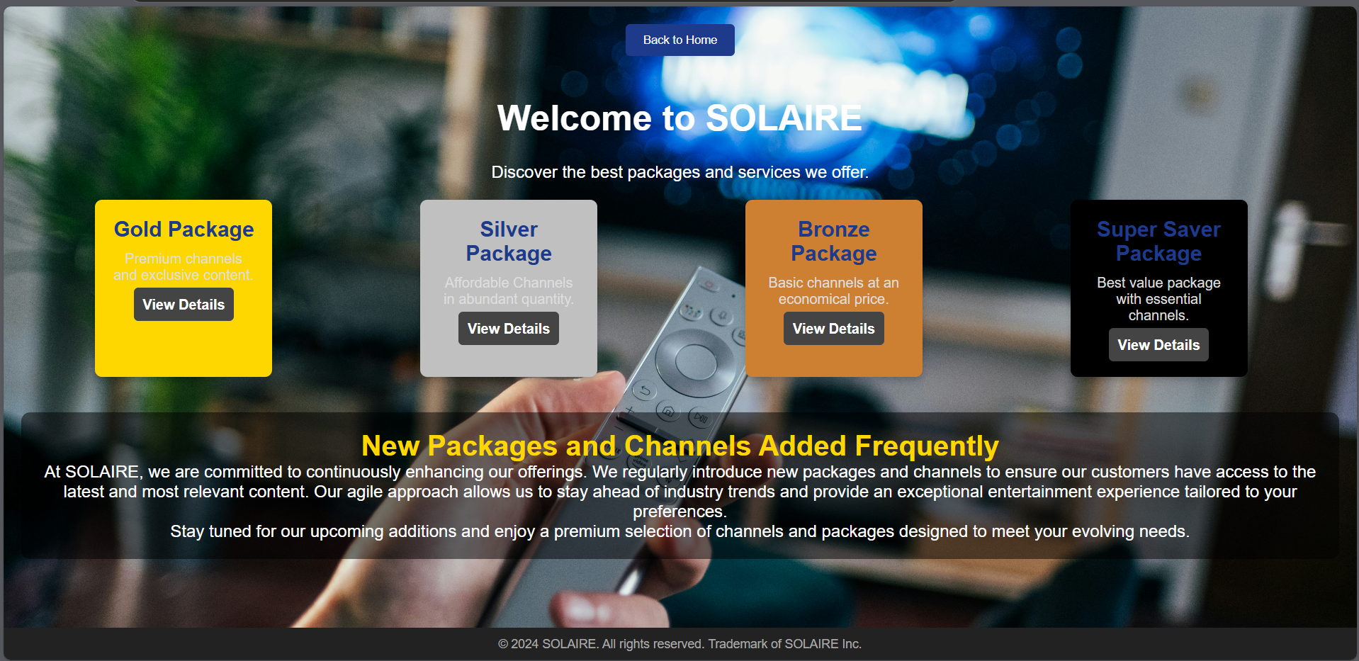

Package Details Page:

The **Package Details Page** offers users a comprehensive overview of available virtual tours or featured content. Users can browse different tours, each showcasing unique multimedia presentations or interactive experiences. Each tour is displayed with key details such as the name, description. The page is designed, with thumbnails and brief descriptions of the Base packages in the cable service. Upon selection, the user is taken to a detailed view PDF with additional information of the channels.

### 6.2.2 Register page:

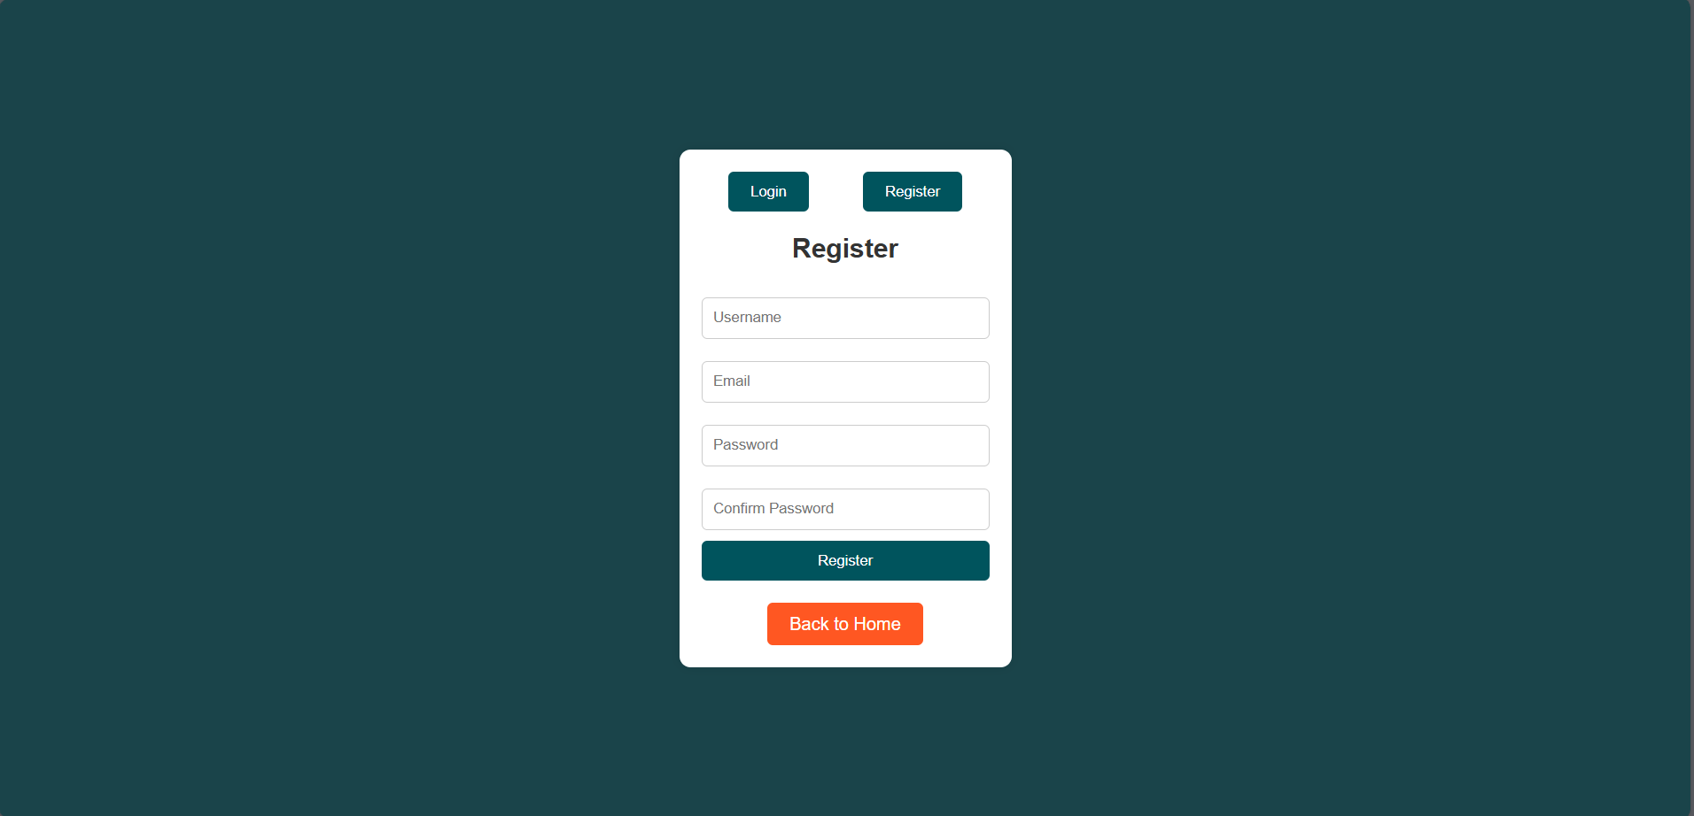

Register Page:

The Register Page allows new users to create an account on the platform. Users provide essential details such as their name, email, and password. There are validation checks to ensure strong passwords and unique email addresses. The page is designed with a simple and user-friendly form layout, making registration easy and fast. Once registered, users can immediately access free content or subscribe to premium packages. Visual indicators help guide users if they make errors during the registration process.

### 6.2.3 Payment page:

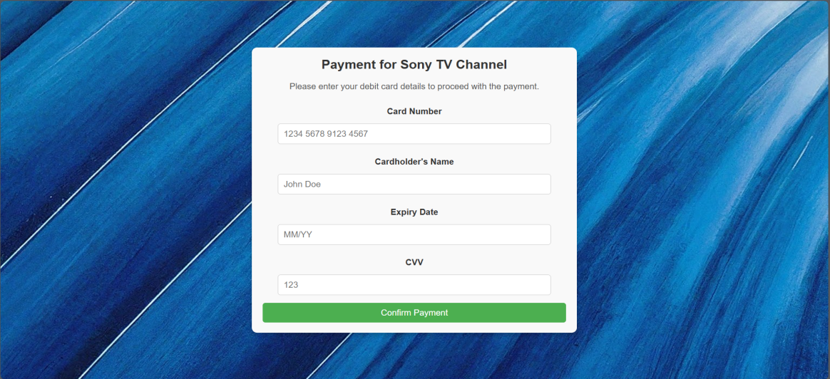

Payment Page:

The Payment Page is where users finalize their subscription or purchase of a channel or package. Users enter credit card details such as card number, expiration date, and CVV to complete the transaction. The form includes validation to ensure correct input of payment information. Pricing details for the selected package or channel are clearly displayed. After confirming payment, users receive a notification and access to their chosen services. The page is secured to protect sensitive payment data.

### 6.2.4 Channels Page:

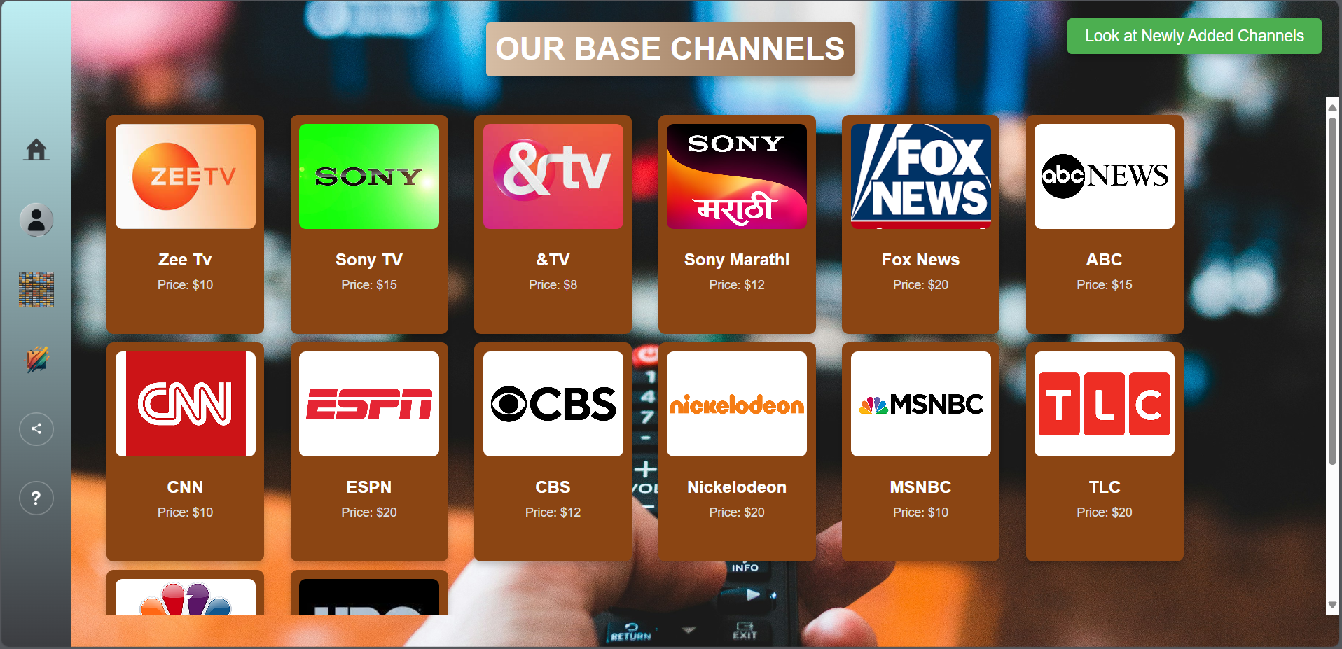

Channels Page:

The Channels Page displays a list of available TV or online streaming channels that users can subscribe to. Users can browse, view, and select channels based on their interests or preferences. Each channel card provides details such as the channel name, pricing, and description. A user can also click on individual channels to view more information or subscribe directly. The page integrates filtering or sorting options to enhance user experience. It's designed to be user-friendly, with a clean layout for easy navigation.

### 6.2.5 User Account Page:

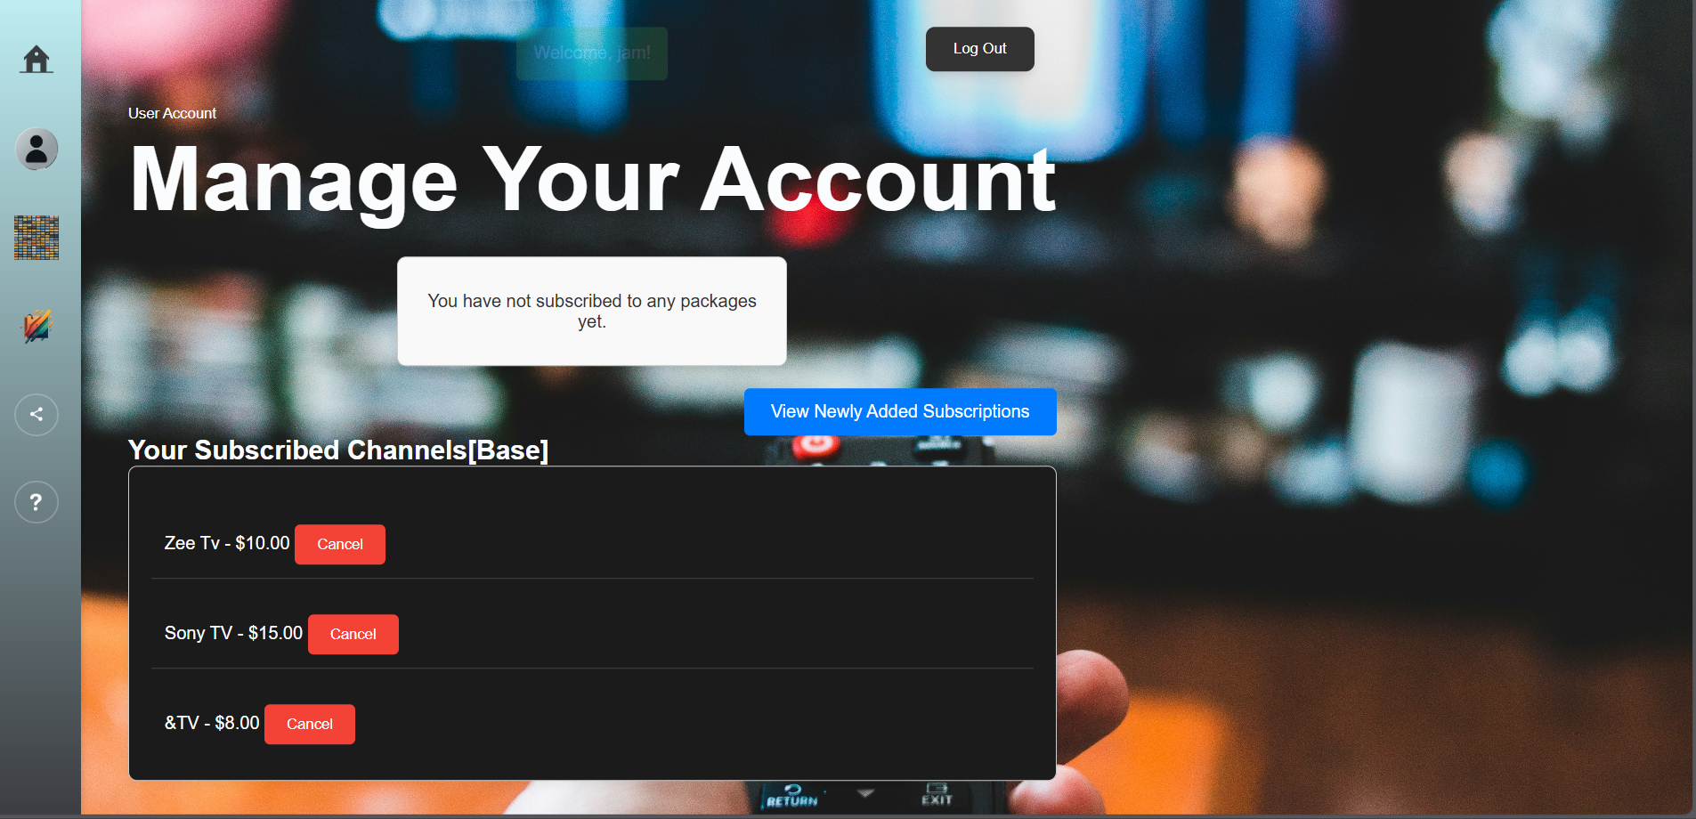

User Account Page:

The User Account Page is where users can manage their personal information and account settings. It includes features such as updating profile details, changing passwords, and viewing subscription history. Users can also see their payment information and manage their subscribed packages or channels. Additionally, the page offers a user dashboard to track their usage or modify notification settings. It's secure and designed to prioritize user privacy and data management.

### 6.2.6 Packages Page:

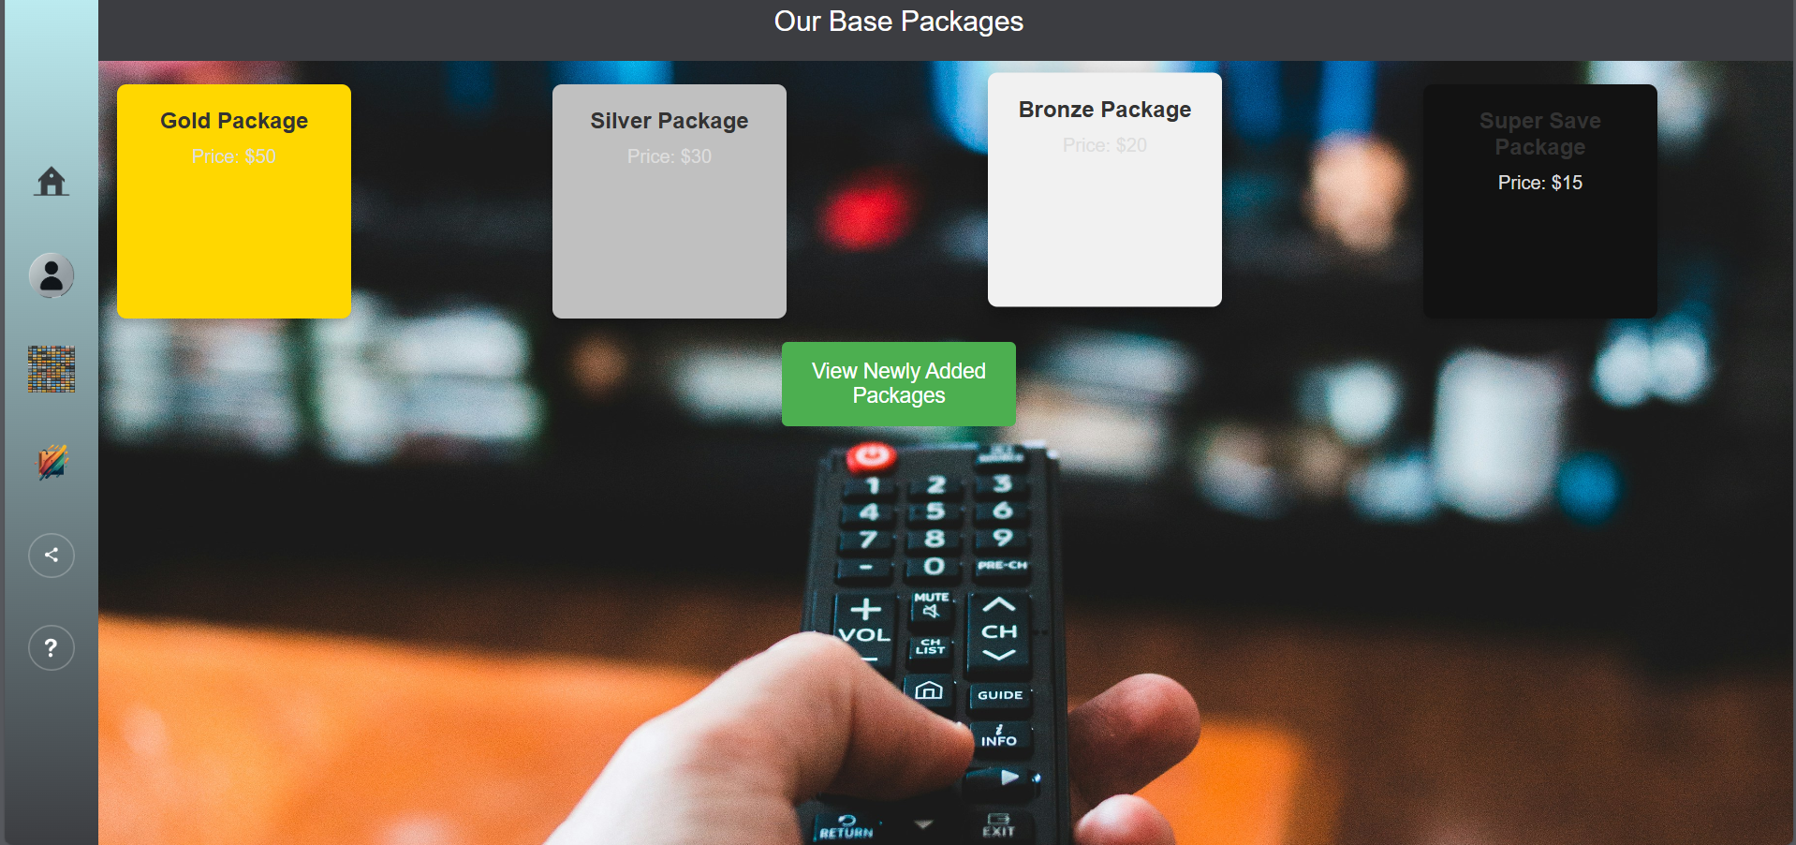

Packages Page:

This page displays the available subscription packages users can choose from. Each package includes a collection of channels or services bundled together for a single price. The page provides a comparison of different packages, showing the included channels, price, and special offers. Users can click on individual packages for more details or proceed with the subscription process. It also integrates payment and account management for ease of use. The layout ensures clarity and user interaction flow.

### 6.2.7 About us page:

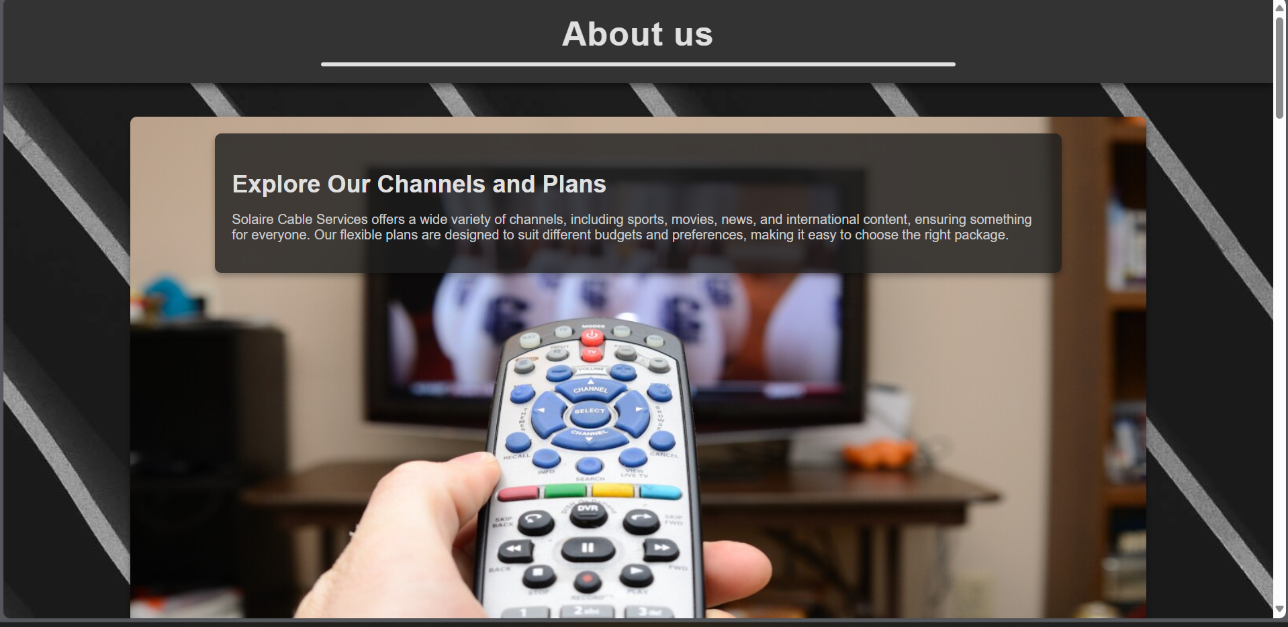

About Us Page:

The About Us Page provides information about the company, its mission, and its services. It highlights the organization's history, values, and the goals it seeks to achieve.A professional and welcoming design invites users to engage.

### 6.2.8 Home page:

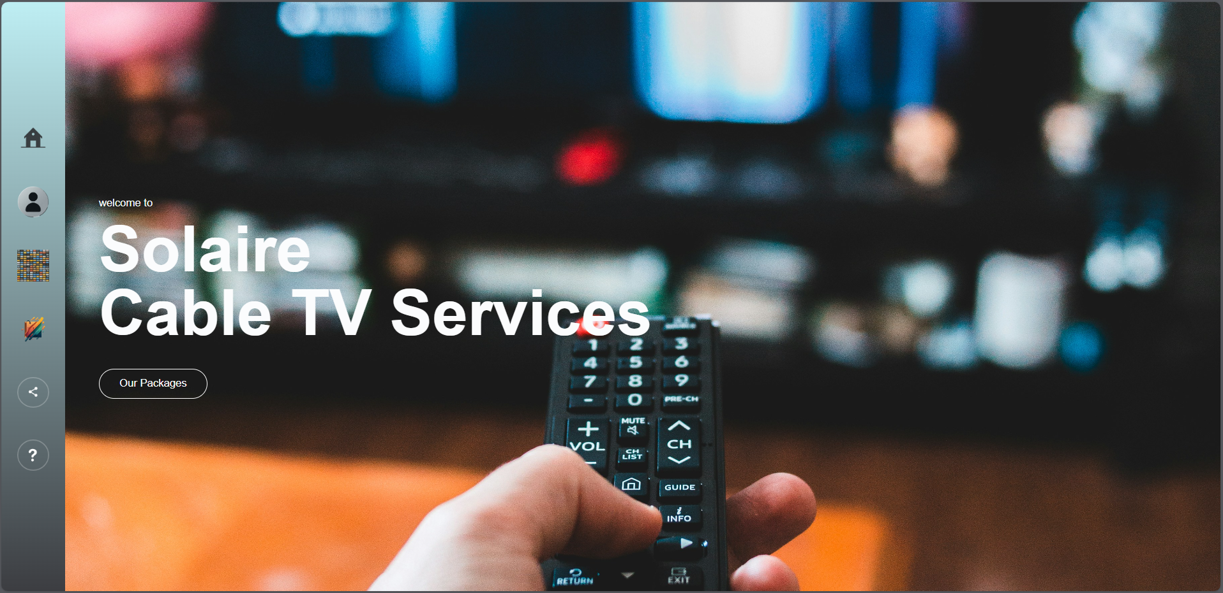

Home Page:

The Home Page is the main landing page, designed to introduce users to the platform’s services and offerings. It features a welcoming design, showcasing the most popular channels, packages, and user benefits. The page also includes a navigation bar and quick links to key features like subscriptions and user accounts. It's visually appealing with dynamic content such as sliders, featured deals, and user testimonials. The primary goal is to capture user attention and guide them to further explore.

### 6.2.9 Login page:

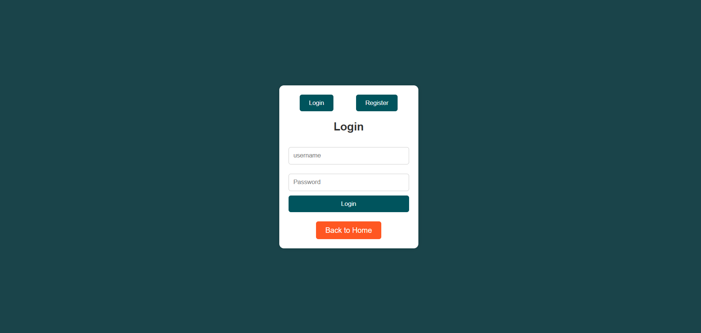

Login Page:

The Login Page is where registered users can access their accounts by entering their credentials. It typically includes fields for username or email and password, with options to recover forgotten passwords. The layout is simple, focused on ensuring fast and easy login. User feedback (such as invalid credentials) is clearly displayed.

### 6.2.10 Admin Dashboard Page:

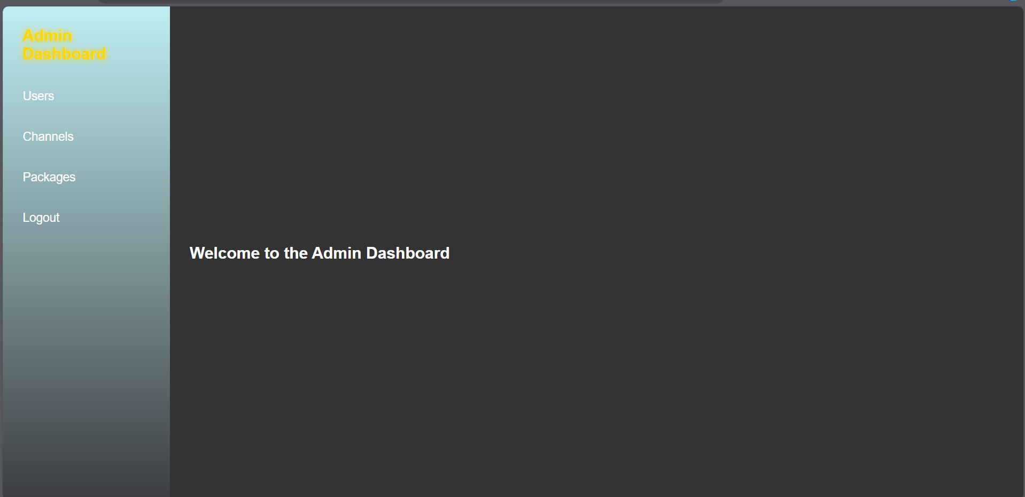

Admin Dashboard Page:

The Admin Dashboard Page provides an overview of key statistics and management tools for the platform. Admins can view user activity, subscription statistics, and system alerts in real-time. The dashboard includes quick links to manage users, channels, and packages

### 6.2.11 admin Users page:

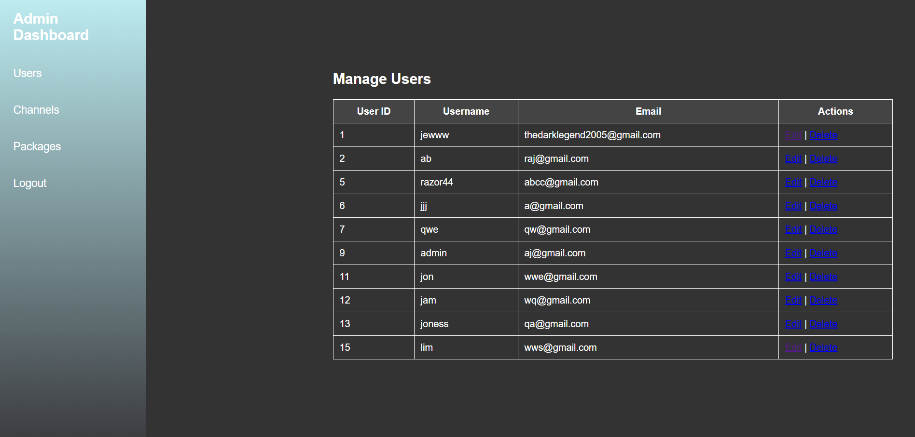

Admin Users Page:

This page allows admins to manage the user base, including editing, or removing users.

### 6.2.12 admin Channel page:

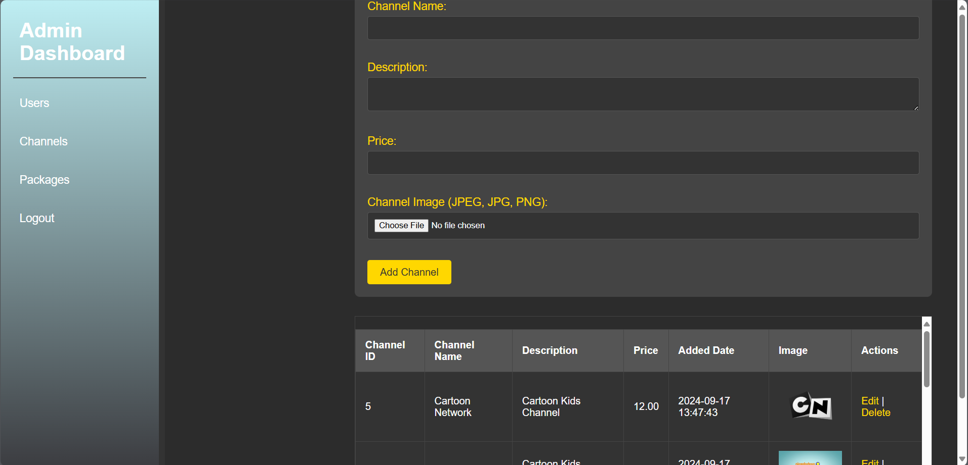Admin Channels Page:

The Admin Channels Page enables administrators to manage the channels offered on the platform. They can add new channels, modify existing ones, or remove outdated channels. The page provides detailed forms for entering channel information such as name, description, pricing, and logos.

### 6.2.13 Admin Package page:

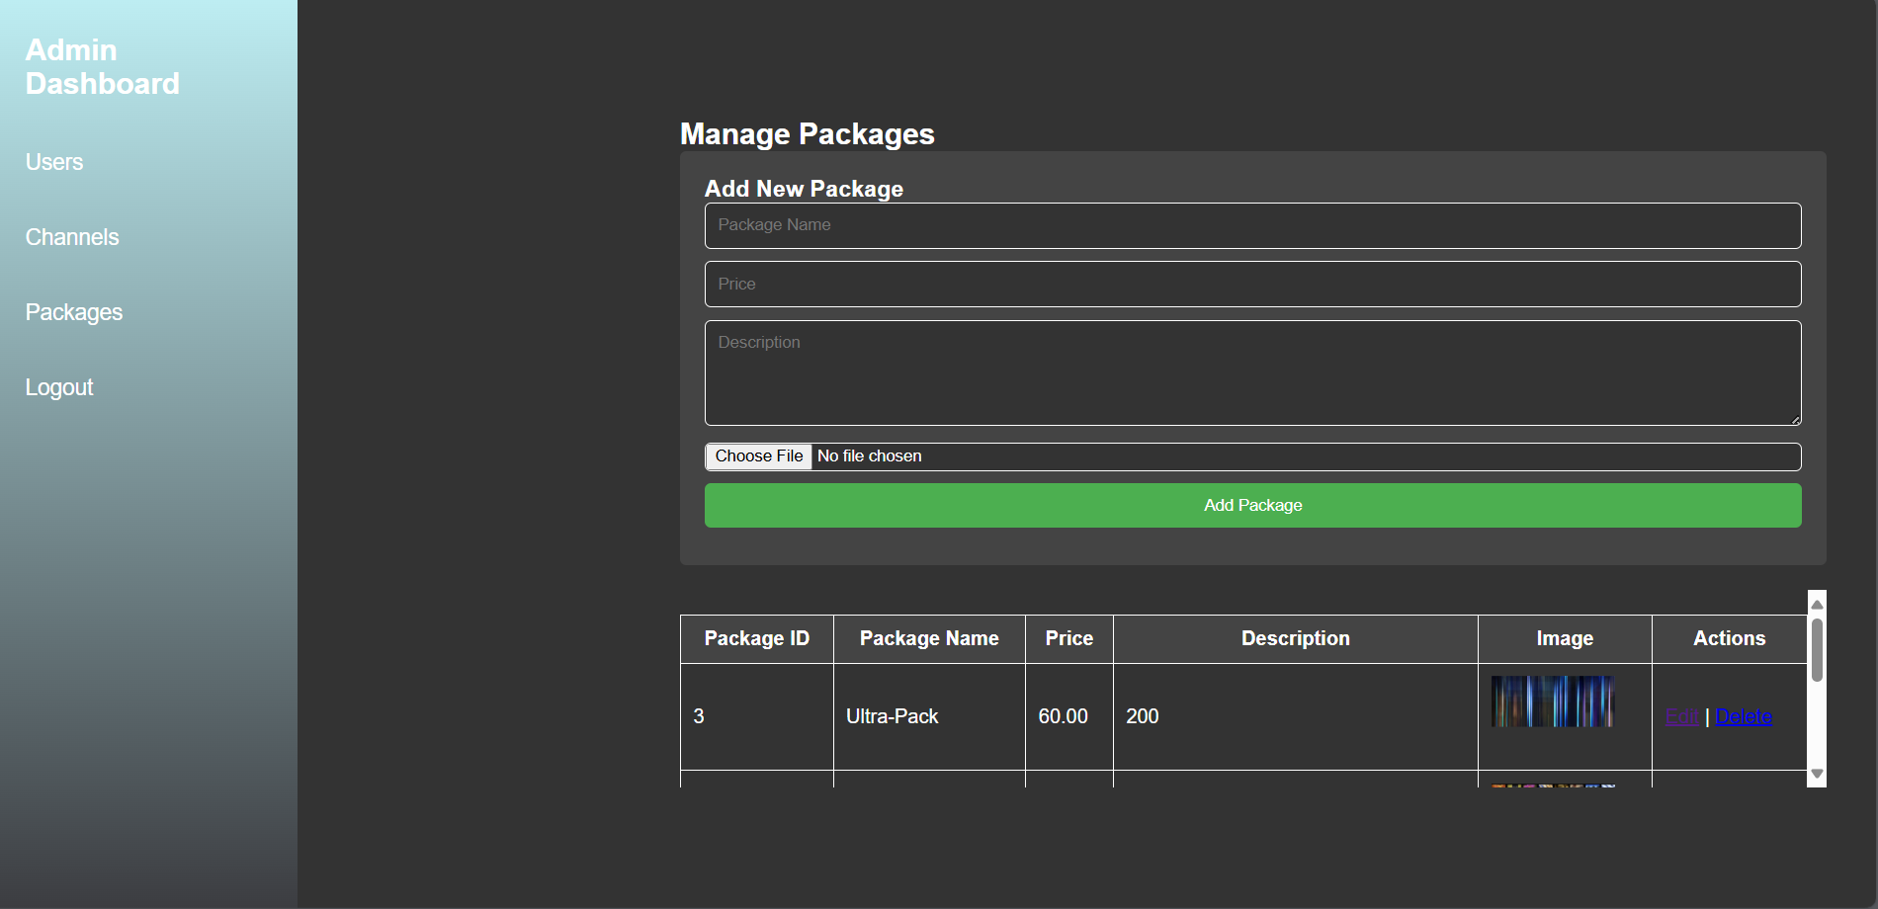

Admin Package Page:

The Admin Package Page is designed to create and manage subscription packages. Admins can bundle channels into various packages and assign pricing models. The page allows for editing package details, including package name, description, and associated channels

# 7. Future Enhancement & conclusion:

## 7.1 Future Enhancement:

* More Channels
* More Packages
* UI Enhancements
* Improved Admin Page

## 7.2 conclusions:

In conclusion, the Solaire Cable Services project has been a significant achievement, marked by creative problem-solving. The journey began with a clear vision of creating a modern, user-friendly platform to enhance cable service management. Throughout the development process, we encountered various challenges, such as integrating a dark-themed design while ensuring readability and maintaining functional design elements. Overcoming these hurdles involved meticulous adjustments and iterative testing to achieve a seamless user experience.

Despite facing hurdles such as intricate technical requirements and design inconsistencies, we turned these challenges into opportunities for refinement and excellence. The final product is a testament to our commitment to quality and user satisfaction, featuring a robust admin dashboard, intuitive user navigation, and cutting-edge functionality.

**Title: Comprehensive Report on Football Game Project**

### **Introduction**

The football game project aims to deliver an immersive and interactive soccer experience by incorporating engaging gameplay mechanics, realistic physics, and user-friendly controls. The game is designed to offer multiple game modes, including penalty shootouts and free kick challenges, allowing players to test their skills in different football scenarios.

The project includes various features such as a dynamic pause menu, scene transitions, collision-based goal detection, and an intuitive UI for navigating between menus and levels. The game leverages Unity’s physics engine to provide realistic ball movement and impact reactions, ensuring an engaging experience for the players.

This document provides a comprehensive breakdown of the game, including its objectives, system design, gameplay mechanics, user interface, challenges faced, and future enhancements that can be incorporated.

---

### **Objectives of the Football Game Project**

1. **Immersive Gameplay Mechanics:** The game aims to simulate real-world football mechanics, allowing players to experience precise ball control, aiming, and shooting techniques.

2. **Multiple Game Modes:** Players can participate in different game scenarios, including penalty shootouts, free kick challenges, and practice mode.

3. **Intuitive UI and Menu Navigation:** A well-designed UI provides easy navigation through different game scenes, including game menus, levels, and settings.

4. **Realistic Physics and AI Goalkeeping:** The game features accurate physics calculations for ball movement, goal-scoring conditions, and goalkeeper responses.

5. **Customizable Sound and Music:** Players can toggle background music and sound effects through the settings menu.

6. **Smooth Scene Transitions and Game State Management:** The system ensures seamless transitions between different levels and menus, allowing for an uninterrupted gaming experience.

---

### **Description of the Current System**

The football game is structured into multiple scenes, each designed to provide a unique experience. The main game menu acts as the hub where players can access different modes. The gameplay system incorporates a ball shooting mechanism, a target-based scoring system, and a goalkeeper AI that attempts to block shots.

The penalty shootout mode consists of a series of rounds where the player attempts to score goals from a fixed position. Free kick mode introduces obstacles like defensive walls, requiring players to aim their shots strategically. Additionally, a practice mode allows unrestricted movement within a stadium-like environment for refining ball control and shooting accuracy.

The game integrates a pause menu that provides options to resume, toggle music, or exit to the level selection menu. Unity's physics engine is used to handle ball movement and collisions effectively.

---

### **Key Features of the Game**

#### **1. Game Scenes and Navigation**

- **Login and Registration Scenes:** Players can create accounts and log in to track their progress.

- **Main Menu:** Provides access to different game modes and settings.

- **Levels Menu:** Displays various game modes, including penalty shootouts and free kick challenges.

- **Gameplay Scenes:** These include penalty shootout rounds, free kick challenges, and a free practice mode.

- **Pause and Settings Menu:** Allows users to pause the game, adjust sound settings, or return to the levels menu.

#### **2. Gameplay Mechanics**

- **Ball Physics:** The game uses Unity's physics engine to ensure realistic ball movement, spin, and collision behavior.

- **Goal Detection:** The game detects when the ball crosses the goal line, updating the score accordingly.

- **Target-Based Free Kick Mode:** Players aim at designated targets to complete challenges.

- **Dynamic Wall Movement:** In some free kick levels, defensive walls move side-to-side, increasing difficulty.

#### **3. Sound and Music**

- **Background Music:** Players can toggle background music on and off from the settings menu.

- **Sound Effects:** Includes ball-kicking sounds, goal-scoring cheers, and goalkeeper reactions.

#### **4. Pause and Exit Functionality**

- Players can pause the game at any time.

- A menu overlay appears, allowing them to resume, return to the level menu, or exit the session.

- Exiting the session does not close the game but instead redirects the player to the level selection scene.

---

### **Game Mechanics and Technical Aspects**

#### **1. Ball Movement and Shooting Mechanism**

The game features a power-based shooting system where players control the direction and force of their shots. The ball follows a realistic trajectory based on Unity’s physics engine.

#### **2. Goalkeeper AI**

In penalty shootout mode, the goalkeeper uses an AI system to predict the ball’s trajectory and attempt to block the shot. The AI difficulty can be adjusted to make the game more challenging.

#### **3. Score Tracking System**

Although initially designed to track player scores, the project has been updated to focus purely on gameplay without tracking scores across sessions. The scoring system updates during each match but does not store data persistently.

#### **4. Target-Based Free Kick Mode**

In free kick mode, players must hit a designated target inside the goal to complete the challenge. The target is set up with a collider to detect ball impact.

---

### **Challenges Encountered During Development**

1. **Collision Detection Issues:** Initially, the ball would pass through colliders, requiring adjustments in mesh collider settings.

2. **UI Scaling Problems:** Ensuring consistent UI scaling across different screen resolutions was a challenge.

3. **Pause Menu Bugs:** The pause menu initially did not reactivate after being used once.

4. **Scene Transitions:** Managing smooth transitions between levels without game object conflicts required optimization.

5. **Goal Detection Accuracy:** Fine-tuning the goal collider to detect valid goals without registering false positives.

---

### **Future Enhancements**

1. **Multiplayer Mode:** Introduce online and local multiplayer options to allow players to compete against each other.

2. **Career Mode:** A progression system where players start as beginners and work their way up to professional leagues.

3. **Enhanced Goalkeeper AI:** Improving goalkeeper reactions to better challenge the player’s skills.

4. **Customizable Player Avatars:** Allow players to create and customize their in-game avatars.

5. **Weather Effects:** Adding dynamic weather conditions such as rain, wind, and snow that affect ball physics.

6. **Replay System:** Enabling players to watch their best goals in slow motion.

7. **Expanded Stadiums and Environments:** Increasing the variety of playing fields for a more immersive experience.

---

### **Conclusion**

The **Football Game Project** successfully delivers an engaging and interactive soccer experience, incorporating well-structured gameplay mechanics, realistic physics, and user-friendly UI navigation. With game modes like **penalty shootouts and free kick challenges**, players can refine their football skills while enjoying an intuitive and immersive gaming experience.

The game's **robust physics system** ensures accurate ball movement, making shots feel responsive and realistic. The **goalkeeper AI**, although currently in its basic form, offers a foundation for future enhancements. **UI elements, including the pause menu and level selection screen,** allow seamless navigation and enhance overall usability.

Despite some initial challenges, such as **collision detection issues and UI scaling problems,** the project successfully overcame these obstacles through careful debugging and optimization. The removal of the **score-tracking system** ensures a gameplay-focused experience, emphasizing skill development over persistent tracking.

Looking ahead, **future updates** may introduce **multiplayer functionality, career progression, and advanced AI mechanics**, further enriching the game. Other enhancements, such as **dynamic weather effects and replay options**, will provide added realism and engagement.

Overall, this football game project lays a **strong foundation** for expansion and improvement, ensuring **long-term engagement and replayability** for players.

Looking ahead, **future updates** may introduce **multiplayer functionality, career progression, and advanced AI mechanics**, further enriching the game. Other enhancements, such as **dynamic weather effects and replay options**, will provide added realism and engagement.

Overall, this football game project lays a **strong foundation** for expansion and improvement, ensuring **long-term engagement and replayability** for players.

Looking ahead, **future updates** may introduce **multiplayer functionality, career progression, and advanced AI mechanics**, further enriching the game. Other enhancements, such as **dynamic weather effects and replay options**, will provide added realism and engagement.

Overall, this football game project lays a **strong foundation** for expansion and improvement, ensuring **long-term engagement and replayability** for players.

Looking ahead, **future updates** may introduce **multiplayer functionality, career progression, and advanced AI mechanics**, further enriching the game. Other enhancements, such as **dynamic weather effects and replay options**, will provide added realism and engagement.

Overall, this football game project lays a **strong foundation** for expansion and improvement, ensuring **long-term engagement and replayability** for players.

Looking ahead, **future updates** may introduce **multiplayer functionality, career progression, and advanced AI mechanics**, further enriching the game. Other enhancements, such as **dynamic weather effects and replay options**, will provide added realism and engagement.

Overall, this football game project lays a **strong foundation** for expansion and improvement, ensuring **long-term engagement and replayability** for players.

Looking ahead, **future updates** may introduce **multiplayer functionality, career progression, and advanced AI mechanics**, further enriching the game. Other enhancements, such as **dynamic weather effects and replay options**, will provide added realism and engagement.

Overall, this football game project lays a **strong foundation** for expansion and improvement, ensuring **long-term engagement and replayability** for players.

Looking ahead, **future updates** may introduce **multiplayer functionality, career progression, and advanced AI mechanics**, further enriching the game. Other enhancements, such as **dynamic weather effects and replay options**, will provide added realism and engagement.

Overall, this football game project lays a **strong foundation** for expansion and improvement, ensuring **long-term engagement and replayability** for players.

Looking ahead, **future updates** may introduce **multiplayer functionality, career progression, and advanced AI mechanics**, further enriching the game. Other enhancements, such as **dynamic weather effects and replay options**, will provide added realism and engagement.

Overall, this football game project lays a **strong foundation** for expansion and improvement, ensuring **long-term engagement and replayability** for players.

Looking ahead, **future updates** may introduce **multiplayer functionality, career progression, and advanced AI mechanics**, further enriching the game. Other enhancements, such as **dynamic weather effects and replay options**, will provide added realism and engagement.

Overall, this football game project lays a **strong foundation** for expansion and improvement, ensuring **long-term engagement and replayability** for players.

Overall, this football game project lays a **strong foundation** for expansion and improvement, ensuring **long-term engagement and replayability** for players.

Overall, this football game project lays a **strong foundation** for expansion and improvement, ensuring **long-term engagement and replayability** for players.

Overall, this football game project lays a **strong foundation** for expansion and improvement, ensuring **long-term engagement and replayability** for players.

Overall, this football game project lays a **strong foundation** for expansion and improvement, ensuring **long-term engagement and replayability** for players.

Overall, this football game project lays a **strong foundation** for expansion and improvement, ensuring **long-term engagement and replayability** for players

improvement, ensuring **long-term engagement and replayability** for players

players

# 8.References:

https://www.w3schools.com/php/php_mysql_prepared_statements.asp

For the database queries

https://learnjavascript.online/

For learning javascript and functions

[CSS · Bootstrap (getbootstrap.com)](https://getbootstrap.com/docs/3.4/css/)

For learning CSS and different types of attributes

[Install PHP - javatpoint](https://www.javatpoint.com/install-php)

For php tutorial

<https://www.guru99.com/php-tutorials.html> :

For the admin interface of website

[PHP MySQL Login System - javatpoint](https://www.javatpoint.com/php-mysql-login-system)

For Login Functionality of website

[CSS Flexbox (Flexible Box) (w3schools.com)](https://www.w3schools.com/css/css3_flexbox.asp)

For learning FlexBoxes

# 9 Annexures

## 9.1 Figure list

4.2 Class Diagram: 8

4.3 Usecase Diagram: 9

4.3.1 Customer Use case Diagram: 9

4.3.2 Admin Use case Diagram: 9

4.4 Sequence Diagram: 10

4.5 Activity Diagram: 11

4.5.1 Activity Diagram (User side) 11

4.5.2 Activity Diagram (Admin side): 12

4.6. State Diagram 13

4.6.1 State Diagram (User side): 13

4.6.2 State Diagram (Admin side): 14

4.7 Package diagram: 15

4.8 Component diagram: 15

4.9 Deployment diagram: 16

## 9.2 Table list

4.1 Event Table : 6

4.10 Database Design: 17

4.10.1 user: 17

4.10.2 channels: 18

4.10.3 packages: 19

4.10.4 user_channels: 20

4.10.5 user_subscriptions: 21

4.10.6 new_channels: 21

4.10.7 new_packages: 22

4.10.8 new_userchannels: 24

4.10.9 new_usersubscriptions: 25

6.1 Validation and Naming Conventions: 80